William Wilson

March 2, 1912 – May 9, 2009

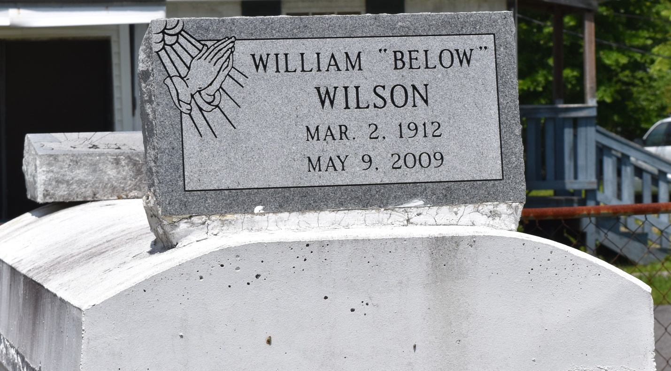

William "Below" Wilson, age 97, a lifelong resident of LaPlace, La., departed this life and entered in eternal rest of Saturday, May 9, 2009 in LaPlace La. Son of the late Julia and Joe Wilson. Husband of the late Olivia Brown Wilson. Father of the late Lawrence Wilson, and stepfather of the late Evelyn Farlough. Also survived by a devoted niece and nephews: Brenda Zeno-Davis, Jacob Jr. and Arthur (Oscar) Zeno; 3 step grandchildren: Naylon Farlough, Nyler William, and Phaedra Grover; 3 great-grand-children: Shanquell Smith, Dejohn Farlough, and Terynek Grover; 2 devoted great-nieces: Angelette Zeno, and Genea Zeno; brother- and sister-in-law; and a host of other relatives and friends.  
  
Pastor, officers and members of Mt. Calvary B.C., and all neighboring churches are invited to attend the Funeral Service on Saturday, May 16, 2009 at 12:00 noon from the Mt. Calvary B.C., 127 W. 3rd St., LaPlace, La. Dr. Rev. Freddie Howard Pastor, Officiating. Interment in Providence Rest Haven Cemetery in LaPlace, La. Visitation from the above named church from 10:00a.m until service time.  
  
Service entrusted to Hobson Brown Funeral Home, Garyville, La, (985) 535-2516

Times-Picayune, The (New Orleans, LA) - Friday, May 15, 2009

Contributed by Jane Edson