Alberta (August) Zeno

November 21, 1929 – April 3, 2006

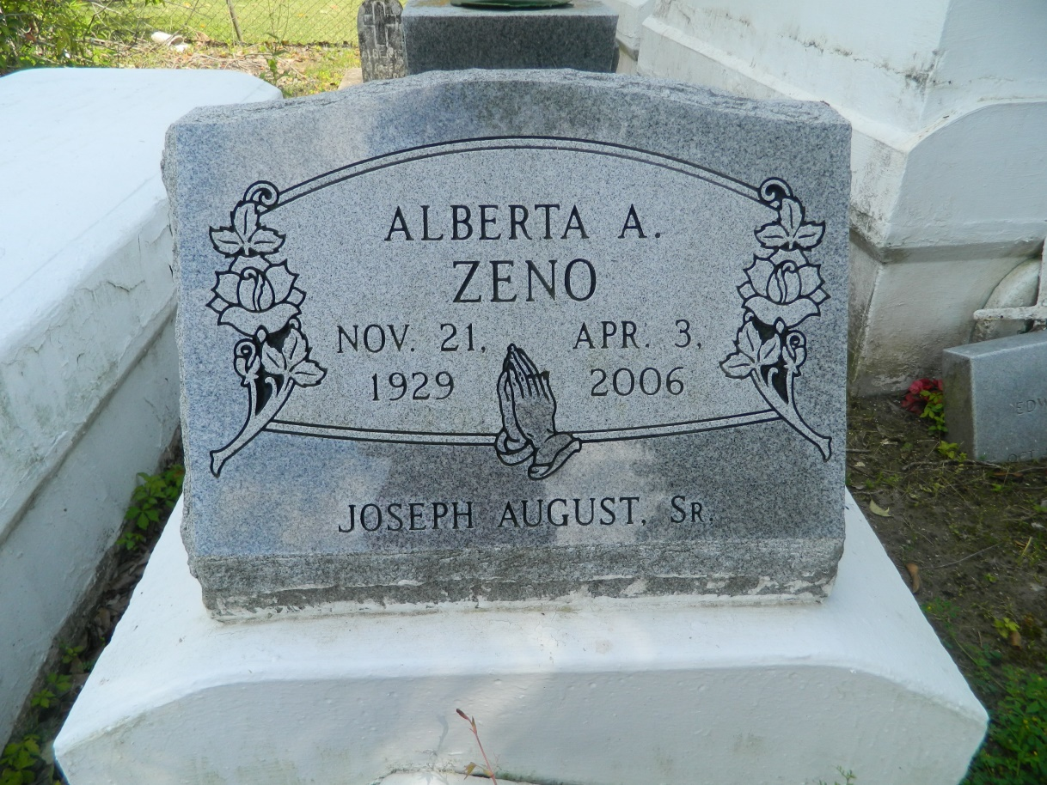

Alberta August Zeno, a homemaker, passed away peacefully on Monday, April 3, 2006 at her home. Age 76 she was a lifelong resident of LaPlace, La. Mrs. Zeno was the daughter of the late Joseph August, Jr., and Leona (Green) August. Loving Mother of Patricia Lewis of Alexandria, VA, Laura Z. Banks, Roberta Z.August, Carolyn Zeno and Leonard Zeno, Jr. Mother in law of Rev. Donald R. August and Claudette Zeno, also survived by (5) Grandchildren, (2) Great Grandchildren. And a host of nieces, nephews other relative and friends. A native and a resident of LaPlace, La.  
  
Members and Friends of Rising Star B.C. and all neighboring churches are invited to attend the Home going service on Saturday, April 8, 2006 at 12:00 noon from the above named church 620 Cardinal St. Laplace, La., Rev. Donald Ray August, Sr., Pastor Officiating, and Interment in Providence Cemetery, Laplace, La., and Visitation from 10:00 a.m. Until Service Time at the Church.  
  
Service Entrusted to Hobson Brown Funeral Home, Garyville, LA.

Times-Picayune, The (New Orleans, LA) - Friday, April 7, 2006

Contributed by Jane Edson