Cynthia Ann (Boudoin) Borne

April 6, 1953 - January 14, 2023

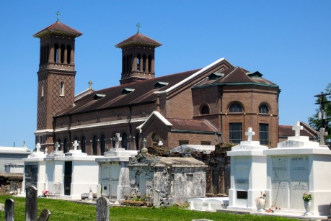

Cynthia Ann Boudoin Borne was born on April 6, 1953, in New Orleans, Louisiana. She was the beloved daughter of the late Louverther Jarrow Boudoin and Joseph Boudoin, Sr. of Edgard, Louisiana. Cynthia entered her eternal home on Saturday, January 14, 2023. Her soul surrendered unto the call of the Heavenly Father to a mansion prepared for her from the foundation of the Earth by an all-wise, loving God.  
 Cynthia loved The Lord and was a lifelong member of St. John the Baptist Catholic Church where she was a devoted CCD teacher for many years. She was the loving, Christian woman God created her to be. Cynthia was educated in the St. John Parish Public School System. She was a graduate of Second Ward High School with  
the class of 1973. After 40 years of hard work and dedication, Cynthia retired from East Jefferson General Hospital as a Courier Supervisor.  
 Cynthia was a member of the Knights of Peter Claver Ladies Auxiliary Court #66. She also served as a member of the St. John the Baptist Catholic Church All Saints Committee, Bingo Committee, 4th of July Committee. She was a member of the West St. John Civic Association.  
 Whenever someone mentions Cynthia’s name the word ‘sweet’ always come up. She had a big heart and showed her love to everyone she came across. She did not know the word ‘no’ when anyone asked her for help. She was a wonderful cook and often ran errands for the shut-in. She also, drove the elderly to doctor’s appointments and the grocery store.  
 Cynthia will always be remembered as a loving wife, devoted mother, doting Momo, wonderful sister, and a sweet caregiver. She was preceded in death by her parents, Louverther Jarrow Boudoin and Joseph Boudoin, Sr.; grandparents, Gregoire and Georgiana Jarrow, and Sylvio and Eunice Boudoin; brother, Julius Boudoin, Sr.; in-laws, Aubrey and Claire Borne III, Diana B. and Jerry Dumas, Sr., Muriel Barrow, Irving Pierre, Jr., Lonnie Borne, Danny Borne.  
 Cherishing her precious memories are: husband, Aubrey Borne, Jr.; children, Corey (Shalanda) Borne, Aubrey (Sonya) Borne III, Jeffery (Dana) Brown, Eric Jefferson, and Demetrice Brown; 24 grandchildren; 15 great-grandchildren; siblings, Gregory (Ida) Barrow, Joseph (Annetta) Boudoin, Jr. Loubertha Boudoin Pierre, Gwendolyn (Vance, Sr.) LaFrance, Michael Boudoin; sisters-in-law, Geraldine Boudoin, Claudia Bailey, Barbara (David) Lewis, Stella Borne, and Daphne Washington; brothers-in-law, Michael Borne, Sr., and Ricky (Dorian); Godchildren, Shannon Boudoin and Chanetta B. Ashford. She is also survived by a host of other relatives and friends.  
 A Mass of Christian Burial will be held on Monday, January 23, 2023, at St. John the Baptist Catholic Church, 2349 LA-18, Edagrd, LA 70049. Visitation beginning at 8am. Mass will begin at 10am. Recitation of the Holy Rosary at 9am. Father Robustiano Morgia, Celebrant. Interment to follow at St. John the Baptist Catholic Church Cemetery. Final care and professional services entrusted to Treasures of Life Funeral Services, 315 E. Airline Hwy., Gramercy, LA 70052.

Treasures of Life Funeral Services, Gramercy, Louisiana