Lloyd Joseph Borne Sr.

October 23, 1946 – November 23, 2006

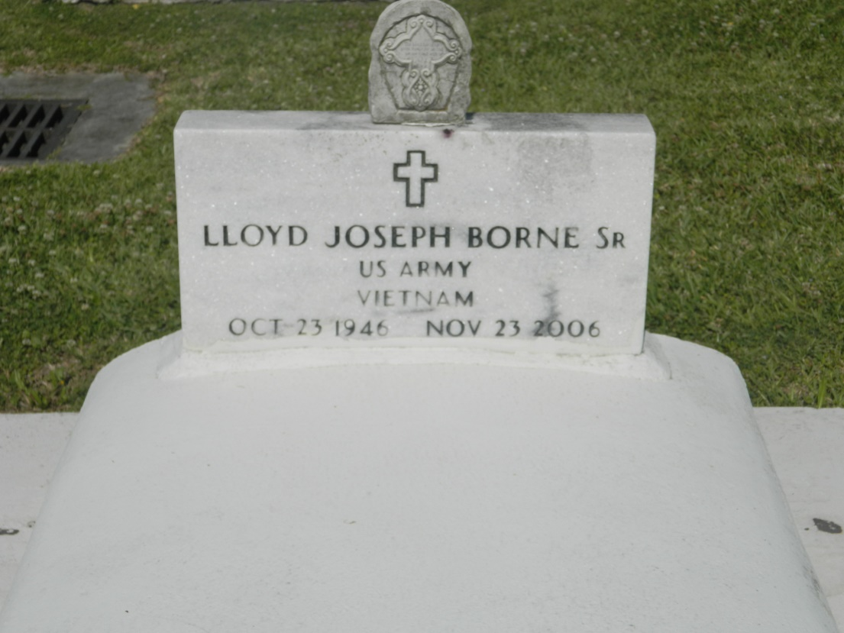

Lloyd J. (Throat) (Yogi) Borne, Sr. passed away at his home on Thursday, November 23, 2006 in Edgard, LA. Son of Florence Edwards Borne and the late Roger Borne, Sr. Husband of Theresa Pierce Borne for 35 years. Loving father of Lloyd "Jake" (Tiffany) Borne, Jr. of Hahnville, LA, Tammy and Monica Borne of Edgard, LA. Guardian of Juwan Batiste. Grandfather of Terry and Domiyon Vinnett and Torin Borne. Great-grandfather of Tiere Vinnett. Brother of Charity (Melvin) Bovie of Edgard, LA, Laura (Charles) Brown of Maryland, Roger J. (Pearl), Herbert, Bridge City, LA, Ronald (Rosie) of Edgard, LA, Henry (Dianne) of Baton Rouge, LA, Mark (Shawan), Davis (Evelyn) of Avondale, LA, Gordon (Kim) of Gramercy, LA, Walter (Amy) Borne of Vacherie, LA and the late Judy Borne. Also survived by a host of aunts, uncles, nieces, nephews, cousins and friends. Lloyd was a U.S. Army veteran. A native and resident of Edgard, LA. Age 60 years.  
 Relatives and friends of the family; also priest and parishioners of St. John the Bapt. Catholic Church and neighboring churches; employees of JE Merit, Dow-Chemical (Union Carbide), Barriere Construction, Colonial Oaks Nursing Home, Tri-Parish Medicaid, St. Charles and St. John Parish Schools and River Region Hospice are invited to attend a Mass of Christian Burial on Saturday, December 2, 2006 at 11:00 a.m. from the St. John the Bapt. Catholic Church, 2361 Hwy. 18, Edgard, LA. Father of Joel Cantones, celebrant. Interment Church Cemetery. Visitation at the Chruch after 9:00 a.m. on Saturday.  
 THE BALONEY FUNERAL HOME, L.L.C., 399 Earl Baloney Dr., Garyville, LA 70051, Information: (985) 535-2540 in charge of arrangements

Times-Picayune, The (New Orleans, LA) - Friday, December 1, 2006

Contributed by Jane Edson