Fernand N. Dinvaut Jr.

February 6, 1909 – January 11, 2003

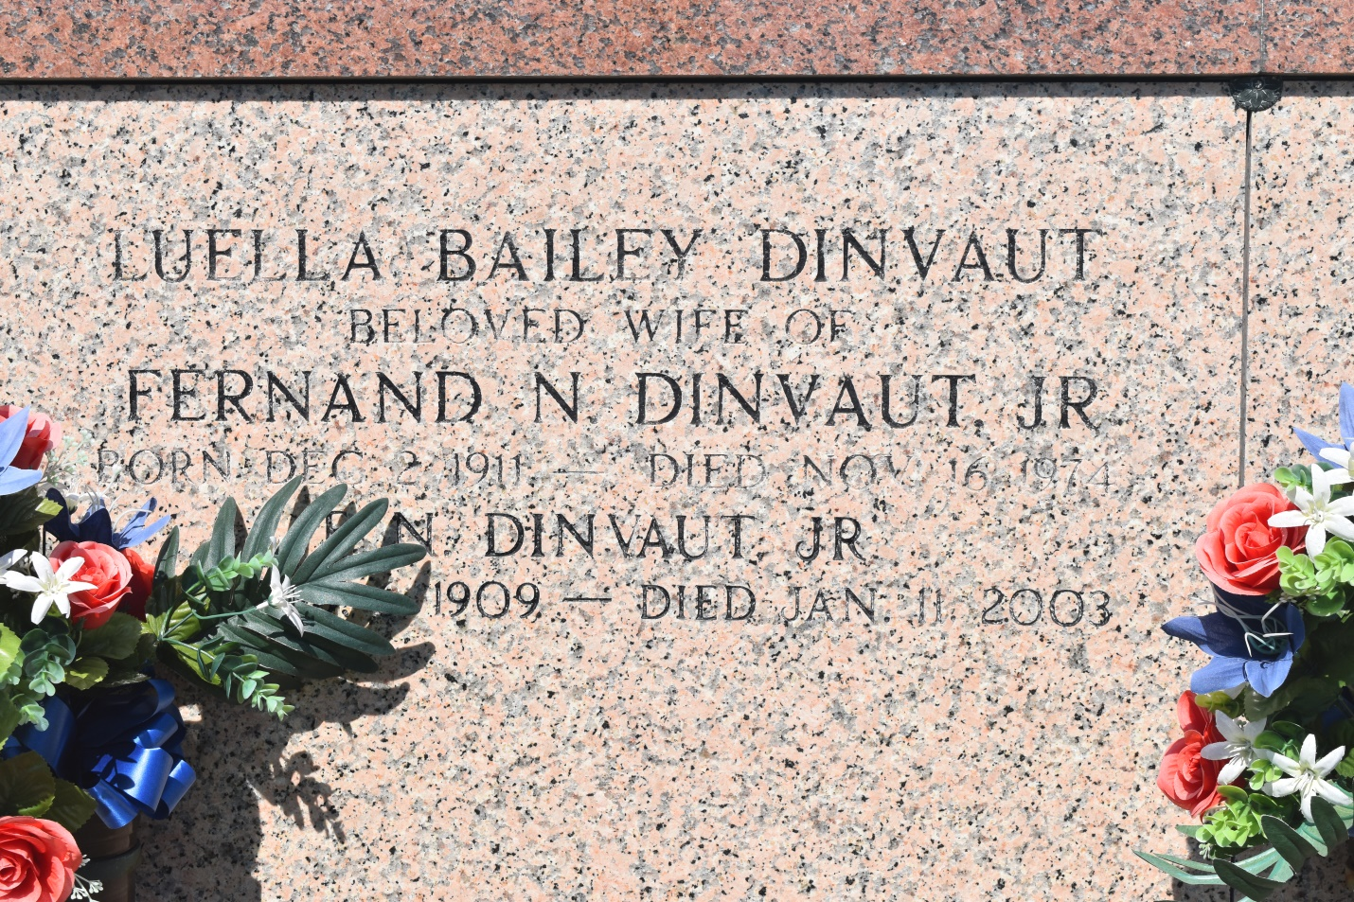

Fernand N. "Kiddo" "Big Daddy" Dinvaut Jr., a retired farmer, died Saturday of natural causes at his home. He was 93. Mr. Dinvaut was a lifelong resident of Edgard. Survivors include two sons, Rudolph Dinvaut and Ferdinand Dinvaut III; three daughters, Rosemary D. Sorapuru, Jacqueline D. Rousseve and Beverly D. Harris; four sisters, Franceline Bordenave, Margaret Darensbourg, Theresa Hicklin and Gloria Allain; 14 grandchildren; and 19 great-grandchildren.

A Mass will be said Wednesday at 11 a.m. at St. John the Baptist Catholic Church in Edgard. Visitation will begin at 9 a.m. Burial will be in the church cemetery. The Baloney Funeral Home is in charge of the arrangements.

Times-Picayune, The (New Orleans, LA) - Tuesday, January 14, 2003

Contributed by Jane Edson