Melvin Andrew Joseph
October 30, 1947 – October 5, 2017

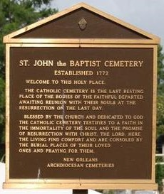

Joseph Melvin Andrew (Nuck)(Pencil) Joseph, of Edgard, La. entered into eternal rest on Thursday, October 5,2017 at the age of 69. He leaves to cherish his memories his loving wife of 49 years, Diann Roussel Joseph, two children Damon (Shawannaka) Joseph of LaPlace,La. and Nikk-Giovanni (Leslie) Gros of Luling, La. His love includes three grandchildren Damani Joseph, Jaden and Bailee Gros, two step grandchildren Alexis and Ttler Gros, three brothers Romalis Joseph of Edgard, La., Christopher (Shelia) Joseph SR., of Boutte, La. Gary (Vangy) Joseph of Humble, Texas, four godchildren Denisse Isom, Keshia Batiste, Demeir Gordon and Jalen Echols. Along with a host of nieces, nephews, aunts, uncles, cousins, other relatives and friends. Preceded in death by his parents Romalis and Thelma Duronslet Joseph.
Relatives and friends of the family, also priest and parishioners of St. John the Baptist Catholic Church, Edgard, La. St. Charles Borromeo Catholic Church, employees of Occidental Chemical Corporation, Denka Performance Elastomers, Dow Chemical Corporation, and United Community Bank are invited to attend a mass of Christian burial on Saturday October 14, 2017 at 11:00am at St. John the Baptist Catholic Church, 2349 Hwy. 18, Edgard, La. 70049. Father Robustiano Morgia and Deacon Warren Pierre celebrants. Visitation at the church after 9:00am on Saturday. Entombment church mausoleum. There will be a gathering of family and friends on Thursday October 12,2017 at Treasures of Life Funeral Services, 315 E. Airline Hwy., Gramercy, La. 5-7pm.

Treasures of Life Funeral Services, Gramercy, Louisiana
October 18, 2018

