Janette (Bovie) LaGrange

October 28, 1942 – February 6, 2015

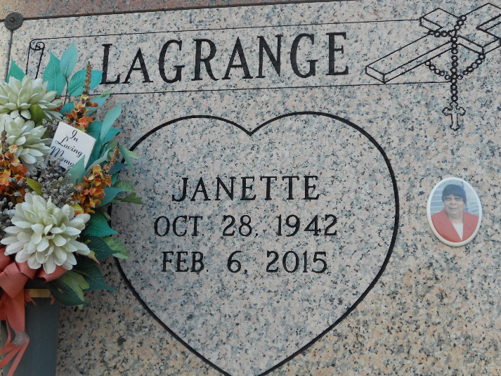

Photo by Team T-Lo

Janette "Cookie" LaGrange of Edgard, LA passed away on Friday, February 6, 2015, age of 72 years old. A native resident of Edgard, LA.  
  
Wife of Herbert LaGrange Sr.; daughter of the late Oscar and Elizabeth Bovie;  
mother of Dana Herbert, Herbert Jr., Treneice (Fabian) Sorapuru, Kai (Rosalind) LaGrange; sister of Natalie B. Miller, Cora Lee Songy, Elizabeth Ann Johnson, Melvin, Oscar Jr., Gene Bovie and the late Rita Jane Barre; niece of Lawrence Pierre, also survived by a host of by eleven grandchildren, six great grandchildren. Survived by a host of sisters-in-law, brothers-in-law, cousins and other relatives and friends.  
  
She was preceded in death by one grandchild.  
  
Relatives and friends of the family, also priest and parishioners of St. John the Baptist Catholic Church, Edgard, LA; Mt. Herman B.C, Avondale, LA; New Jerusalem B.C., Edgard, LA; employees of Ochsner Medical Clinic, Home Depot, DOW, Cajun Construction are invited to attend a Mass of Christian burial on Saturday February 14, 2015, 11:00 am at St. John the Baptist Catholic Church, 2349 Louisiana Hwy 18, Edgard, LA 70049. Visitation at the church beginning at 9:00 am, Recitation of the rosary at 10:00 am. Entombment, Church Cemetery.  
  
Arrangements by Heritage Funeral Directors (504) 944-5500. Funeral Directors, Carmen and Shelia Baloney. Online guest registry @www.heritagefuneraldirectors.com  
  
The Times-Picayune, New Orleans, Louisian

Feb. 12 to Feb. 13, 2015