Leonie (Millet) Roussel
February 1877 – August 6, 1913

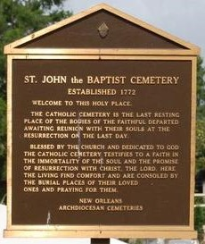
EDGARD, LA., Aug. 7. – The funeral of Mrs. Oliver Roussel, nee Leonie Millet, took place this morning at St. John the Baptist Church, Rev. Charles Richard officiating. Mrs. Roussel, who was 37 years of age, was the mother of six children. Besides her husband she leaves five sisters and six brothers and an aged father and mother to mourn her loss. While Mr. and Mrs. Roussel have been residing at Gramercy, in St. James Parish, since a few years, they are both from St. John the Baptist Parish. The funeral was attended by a large concourse of relatives and friends, not a few coming from distant parts.

Times Picayune, New Orleans, Louisiana
Aug. 8, 1913, p. 8
**

Louisiana, U.S., Compiled Marriage Index, 1718-1925

Name Leontine Millet
Marriage Date 27 Feb 1897
Marriage Place St. John the Baptist, Louisiana, USA
Spouse Olivier Roussel
**

Louisiana, U.S., Statewide Death Index, 1819-1964

Name Leonie Millet
Age 37
Birth Year abt 1876
Death Date 6 Aug 1913
Death Place Orleans, Louisiana, USA

