Bret James Acosta

October 23, 1964 – December 18, 2012

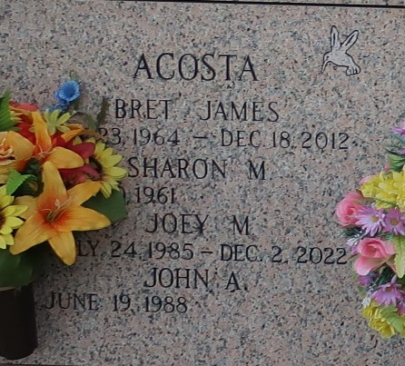

Bret James Acosta, beloved husband of Sharon Monnerjahn Acosta; father of Joey and John Mantia and Juliann Acosta, passed away on December 18, 2012 at the age of 48. He was a native of LaPlace and a resident of Garyville. He was the beloved son of Lynne Laiche Acosta and the late Ronald Joseph Acosta of LaPlace; brother of Ann Engnath (Troy) of Little Rock, AR, Joel Baer (Tom) of Montz, LA and the late Kyle Acosta. He was the uncle of Ashlee, Caroline, Kate, Emily, Grace, Elijah, Olivia, David, and Derrick. He was a member of St. Hubert's Church in Garyville, LA and a member of the Garyville Fire Department, Holy Name Society, Knights of Columbus, and Men's Prayer Group.

Rose Lynn Funeral Home, Lutcher, Louisiana