Joey Mantia Acosta

July 24, 1985 – December 2, 2022

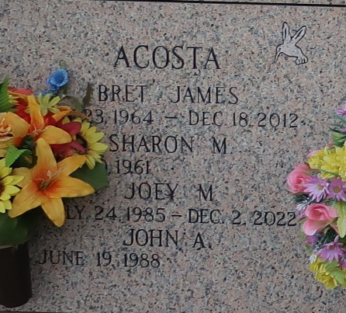

Joey Mantia passed away on Friday, December 2, 2022, in Hammond, Louisiana at the age of 37.  He was born on Wednesday, July 24, 1985 in Metairie, Louisiana to Sharon Acosta. Along with Sharon, Joey was raised by his stepfather the late Bret Acosta.  He was a resident of Hammond, Louisiana. Joey was a loving person with the purest heart, who always wore a smile. Even with no words, Joey was able to express his love, and was able to make his presence known. He loved to go for long walks and could go for miles, his favorite foods were hamburgers and 3 musketeers. Although Joey couldn’t tell you, he was able to let the world know what was on his mind.  He knew how to let you know what he thought without a word. He lit up the world with his smile and brought joy to anyone he came across. Joey is free to use his voice now as he pleases. He is now free to travel wherever his heart takes him.

Joey is survived by his mother, Sharon Acosta, sister and brother-in-law, Juliann Cleveland (Josh), brother, John Acosta, as well as his nieces, Riley and Carly Cleveland.

He was preceded in death by his loving stepfather Bret Acosta.

Harry McKneely & Son Funeral Homes, Hammond, Louisiana

May 13, 2023