Cornell Adams

August 26, 1970 – July 25, 2014

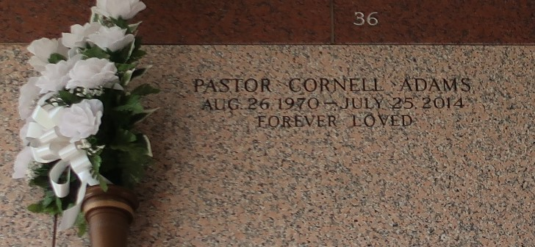

Pastor Cornell Adams, Pastor of Voice of Truth Fellowship Church of LaPlace passed away on Friday, July 25, 2014.  
 He was preceded in death by his parents, Louis and Brookie Adams, Sr. of Garyville, La.; grandparents, Ernest and Mildred Taylor, Louis and Dorothy Adams and Virginia Walker.  
 He leaves to cherish his memories his beloved wife, Laurie Taylor-Adams; his children, Derrius, Dana, and Whitney; 2 grandchildren, Dare'Yona and Derrius, Jr.; siblings, Louis Adams, Jr. and Centilla (Dwayne), his Voice of Truth Church family, aunts, uncles, other relatives, brother in laws and friends.  
 Relatives and friends of the family are invited to attend his Celebration of Life Service on Saturday, August 2, 2014, 11:00AM at Lifehouse Church (Formerly Reserve Christian Fellowship) 3556 W Airline Hwy., Reserve, Louisiana. Host Pastor Stephen Augillard. Officiating Pastor Derrius Taylor of Voice of Truth Church. Visitation will be held from 10:00AM until the hour of service. Interment St. John Memorial Gardens Cemetery.  
 Services entrusted to the caring staff of: Professional Funeral Services, "Divine, A New Dimension of Service", 1449 N. Claiborne Avenue, New Orleans, LA 70116, (504) 948-7447

Times-Picayune, The (New Orleans, LA) - Friday, August 1, 2014

Contributed by Jane Edson