Davin Michael Adams

May 22, 1984 – August 20, 2005

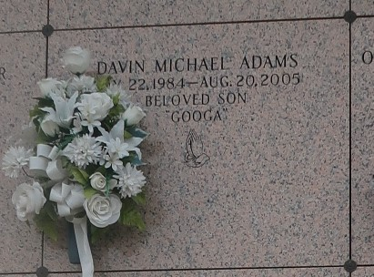

Davin "Googa" Adams, a construction worker with L.G. Builders, died Aug. 20 at Charity Hospital of injuries received in a train accident. He was 21. Mr. Adams was a lifelong resident of Reserve. Survivors include his father, Eric Adams; his mother, Latrichia Gerard Adams; and his grandparents, Henry and Lucille Adams and Ceola B. Gerard.

A Mass will be said today at 11 a.m. at Our Lady of Grace Catholic Church, 774 Louisiana 44, Reserve. Visitation will begin at 9 a.m. Burial will be in St. John Memorial Cemetery. Hobson Brown Funeral Home is in charge of arrangements.

Times-Picayune, The (New Orleans, LA)

Saturday, August 27, 2005

Contributed by Jane Edson