Lucille Theresa (Hilaire) Adams

October 31, 1931 – March 24, 2017

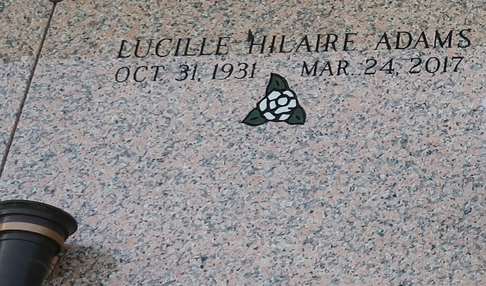

Lucille Theresa Hilaire Adams, a homemaker departed this life on March 24, 2017 Daughter of the late Ignace Hilaire and Amelia Morris Hilaire. Wife of the late Henry Adams Jr., Mother of Jennifer (Gregory) Brooks, Ken(Ebonee), Eric Adams and the late Karl Sr., and Jeffery Adams, Sister of Amelia Roussell, Joseph (Helen) Hilaire, Evelyn Barre, Juanita Green and the late Beatrice (Harold) Roberts, Antionette (James) Tanner, Warren (Ursula) Hilaire, Edith Meadoux, Geda (Paul Sr.), Landreaux and Betty (Earl) Linton. Also, survived by a host of grandchildren, nieces, nephews, other relatives and friends. In lieu of flowers please make donations to Our Lady of Grace Catholic Church. Celebration Mass services will be on Monday April 3, 2017at 10:00am at Our Lady of Grace Catholic Church 772 Hwy 44 Reserve, La Father Christopher Amadi Officiating Interment: St. John Memorial Gardens. Rosary at 9:15am Visitation at 8:15am until service time. Service entrusted to HOBSON BROWN FUNERAL HOME, 134 DAISY ST. GARYVILLE, LA, (985) 535-2516.

Published by The New Orleans Advocate from Mar. 29 to Apr. 3, 2017.