Lloyd E. Addison

March 5, 1920 – June 1, 1981

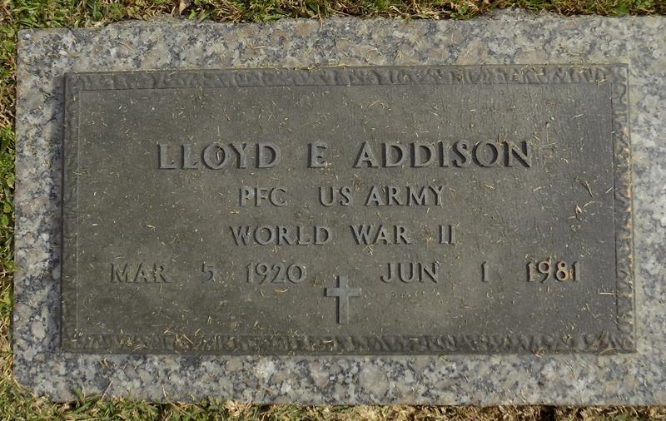

Lloyd E. Addison Sr., on Monday, June 1, 1981 at 3 a.m. beloved husband of Evelyn T. Addison, father of Lloyd Jr., Cheryl and Bonnie Addison, grandfather of Jennifer and Sandra Addison, age 61, a native of New Orleans and a resident of LaPlace for the past 13 years.

Relatives and friends of the family are invited to atten the Funeral Services from Millet Funeral Home, LaPlace, La. On Thursday, June 4, 1981 at 10 a.m. followed by religious services at Funeral Home. Interment St. John Memorial Cemetery, LaPlace. Friends may call from 5 to 10 p.m. on Wednesday, June 3, 1981 and from 8 a.m. until services on Thursday.

Times-Picayune, New Orleans, LA; June 3, 1981