Donald B. Albares

March 11, 1933 – June 11, 2005

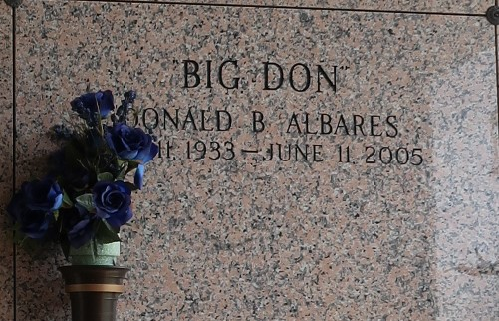

Donald B. Albares, a retired manager of the former Lakeside Health Club, died Saturday of an apparent heart attack at River Parishes Hospital. He was 72. Mr. Albares was born in New Orleans and lived in LaPlace for 11 years. He graduated from Alcee Fortier High School and was a former employee of Wal-Mart. He was a former Mr. New Orleans. He was a parishioner of St. Joan of Arc Catholic Church. He was a longtime member of the Veterans Umpires Association.

Survivors include a son, Donald G. Albares; a brother, Brian J. Albares; and two grandchildren.

A Mass will be said today at 11 a.m. at Millet-Guidry Funeral Home, 2806 W. Airline Highway, LaPlace. Visitation will begin at 9 a.m. Burial will be in St. John Memorial Gardens.

Times-Picayune, The (New Orleans, LA) - Wednesday, June 15, 2005 Contributed by Jane Edson