Stanley E. Alexis Sr.

July 24, 1952 – December 18, 2021

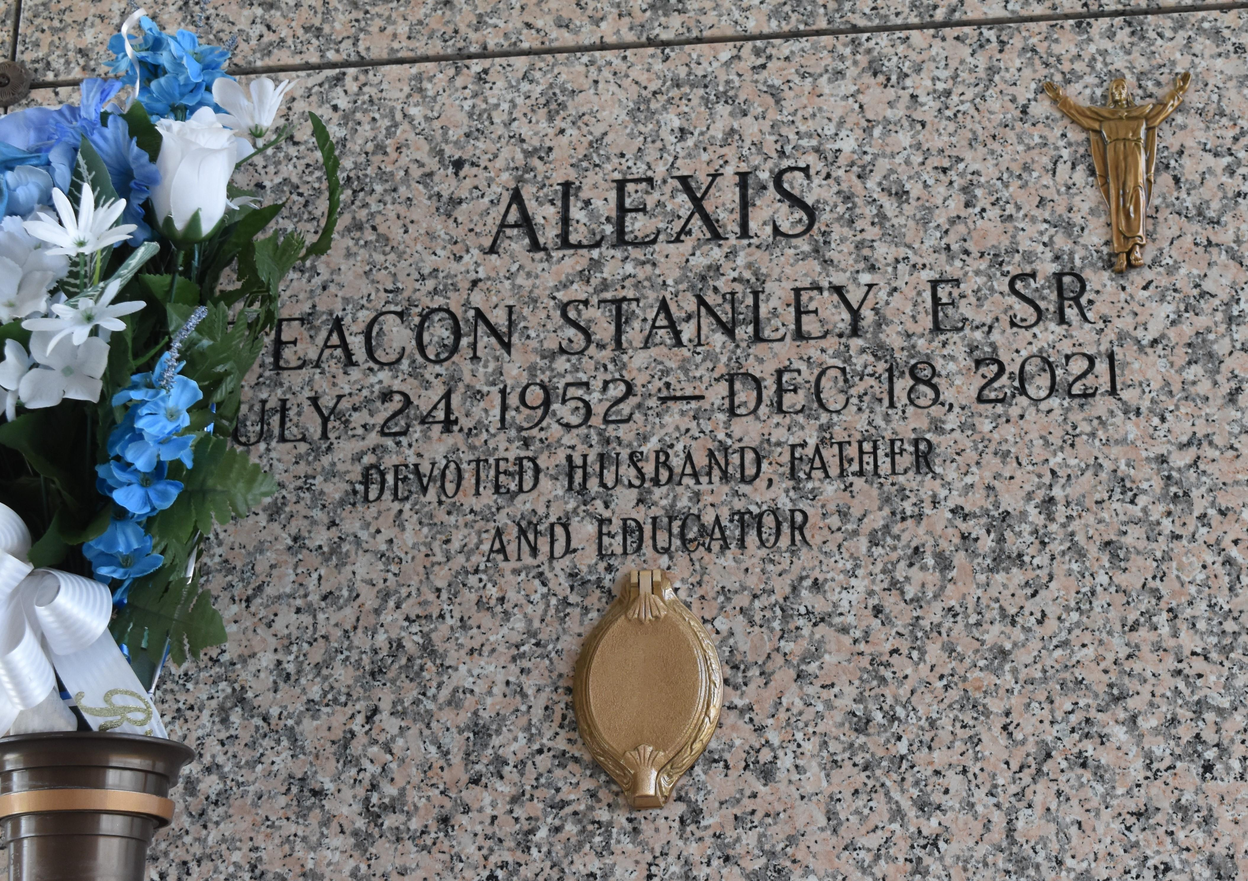

On Saturday, December 18, 2021, at 5:15 a.m., Deacon Stanley "Ricky" Alexis, Sr. passed away at his home in LaPlace. Stanley is the son of the late Maryland Alexis Eugene and the late Johnny Eugene. He was born on July 24, 1952. He leaves to cherish his memories: his wife, Joyce Taylor Alexis; his children, Stanley Alexis, Jr., and Olivia Alexis; his brother, Dwight Alexis, Sr. and his wife, Dr. Katie Babineaux Alexis; his sister-in-law, Pamela Taylor Fleming and her husband, Troy Fleming; his Eugene's step siblings; and a host of other relatives and friends.

He was preceded in death by his brothers, Vernon Alexis, Sr. and Edward Stewart, Jr.

A Celebration of Life Service will be held on Tuesday, December 28, 2021, at 10 a.m. at St. Mark Baptist Church, 132 Marquez St., Mt. Airy, LA. Visitation will be from 8 a.m. until service time. Elder Oscar Nelson officiating. Viewing will be held on Monday, December 27, 2021, from 3 p.m. until 6 p.m. at Millet-Guidry Funeral Home, 2806 W. Airline Hwy, LaPlace, LA. The Family request those who attend to wear masks and practice social distancing. Arrangements by Millet-Guidry Funeral Home. To view or sign the online guest book, please visit [www.milletguidry.com](http://www.milletguidry.com/).

The Times-Picayune (New Orleans, LA) from Dec. 25 to Dec. 27, 2021.