Lawrence James Anderson Sr.

March 13, 1945 – October 17, 2012

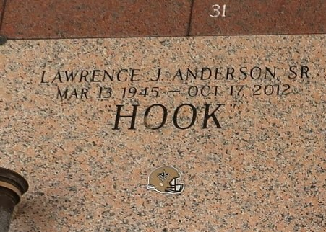

Lawrence James Anderson, departed this life on Wednesday, October 17, 2012 at the age of 67; Beloved husband of Linda Anderson; Also survived by 13 children, 6 brothers, 1 sister and a host of grandchildren, great grandchildren, nieces, nephews, cousins, other relatives and friends.

Relatives and friends of the family are invited to attend the Funeral Mass of Christian Burial at Our Lady of Grace Catholic Church, 772 Hwy. 44, Reserve, LA on Wednesday, October 24, 2012 at 11:00 am; Visitation will begin at 9:00 am; Interment: St. John Memorial Chapel Cem., Laplace, LA;

Arrangements by DW Rhodes Funeral Home, 3933 Washington Ave.; Please visit www.rhodesfuneral.com to sign the guest book.

Times-Picayune, The (New Orleans, LA) — Sunday, October 21, 2012 Contributed by Jane Edson