Wesley Anderson, Sr.

November 25, 1929 –December 13, 2019

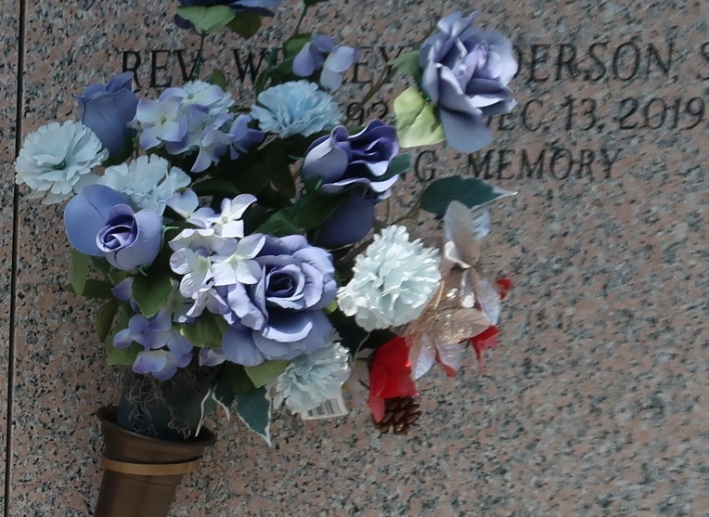

Wesley Anderson, Sr. was born in Gloster, Mississippi, on November 25, 1929 to the late Milton Anderson and Hattye Bates Anderson. He was affectionately known as “Rev” and “Papa”. He made his triumphant transition to glory on December 13, 2019, peacefully surrounded by family.   
 He served faithfully as the loving, devoted Pastor of the Beech Grove Baptist Church of Reserve, Louisiana for 53 years and the True Light Baptist Church of Garyville, Louisiana for 49 years, and 4 years as Assistant Pastor. His sacrifice and service as Pastor of the True Light Baptist Church remained until his transition. He trusted God completely and listened daily for God’s instructions and stood firm on his favorite scripture, Philippians 4:13 “I can do all things through Christ which strengthens me.” He was a Pastor, teacher and mentor that left a lasting impression on those who crossed his path.   
 He was a long-time resident of Garyville, Louisiana. Pastor Anderson worked at Godchaux Sugar Refinery in Reserve, Louisiana for many years until his retirement. He was noted to be very loving and friendly. He was especially known for his huge heart of giving.  
 Pastor Anderson was married to the late Mary Louise Anderson until her death in 2002. He was the devoted father of Mary Ann Cambre of Reserve, Louisiana, Joyce Anderson Washington (Walter Sr.) of Broken Arrow, Oklahoma, Dr. Wesley Anderson, Jr. (Ruth) of Laplace, Louisiana, Russell Anderson of Garyville, Louisiana, and the late Avis Anderson Morris. He and his wife Mary also reared the late Karen Wilson.   
 Reverend Anderson loved to sing. He was a member of the Spiritual Travelers where he served with profound enthusiasm. He was also a member of several organizations to include the Central Union Missionary Baptist Association and the St. John Ministerial Committee.  
 Reverend Anderson leaves behind to celebrate his life his 4 children, his siblings Fannie Hunley of Missouri, Wendell Anderson, David Anderson and Malcolm Anderson of Hammond, Louisiana, and Barbara Jean Alexander of Illinois; 20 grandchildren, 28 great grandchildren, and 7 great, great grandchildren and a host of nieces and nephews. He was preceded in death by his parents, his wife, his daughter, and siblings Julius Anderson and Alma Anderson Thompson.  
 Pastor Anderson was selfless, lived to please God and allowed God to order his steps. He was a great example of a man that followed God, and his legacy has followed him to heaven.   
 Family and friends will be able to pay respects during a viewing to be held at 5:00 – 7:00 pm on Friday, December 20, 2019 at Treasures of Life Center for Life Funeral Services, 315 E. Airline Highway, Gramercy Louisiana. Funeral services will be held at 11:00 am on Saturday, December 21, 2019 at True Light Baptist Church, 258 S. Little Hope Street, Garyville, Louisiana. Visitation begins at 8:00 am. The family will receive friends prior to the service on Saturday from 8:00 am – 10:45 am. Entombment will follow at the St. John Memorial Gardens at 2205 W. Airline Highway in Laplace, Louisiana. Final care entrusted to Treasures of Life Funeral Services, 315 E. Airline Highway, Gramercy, LA 70052.

Treasure of Life Funeral Services, Gramercy, Louisiana