Alvin J. Arabie

May 11, 1930 – April 27, 2011

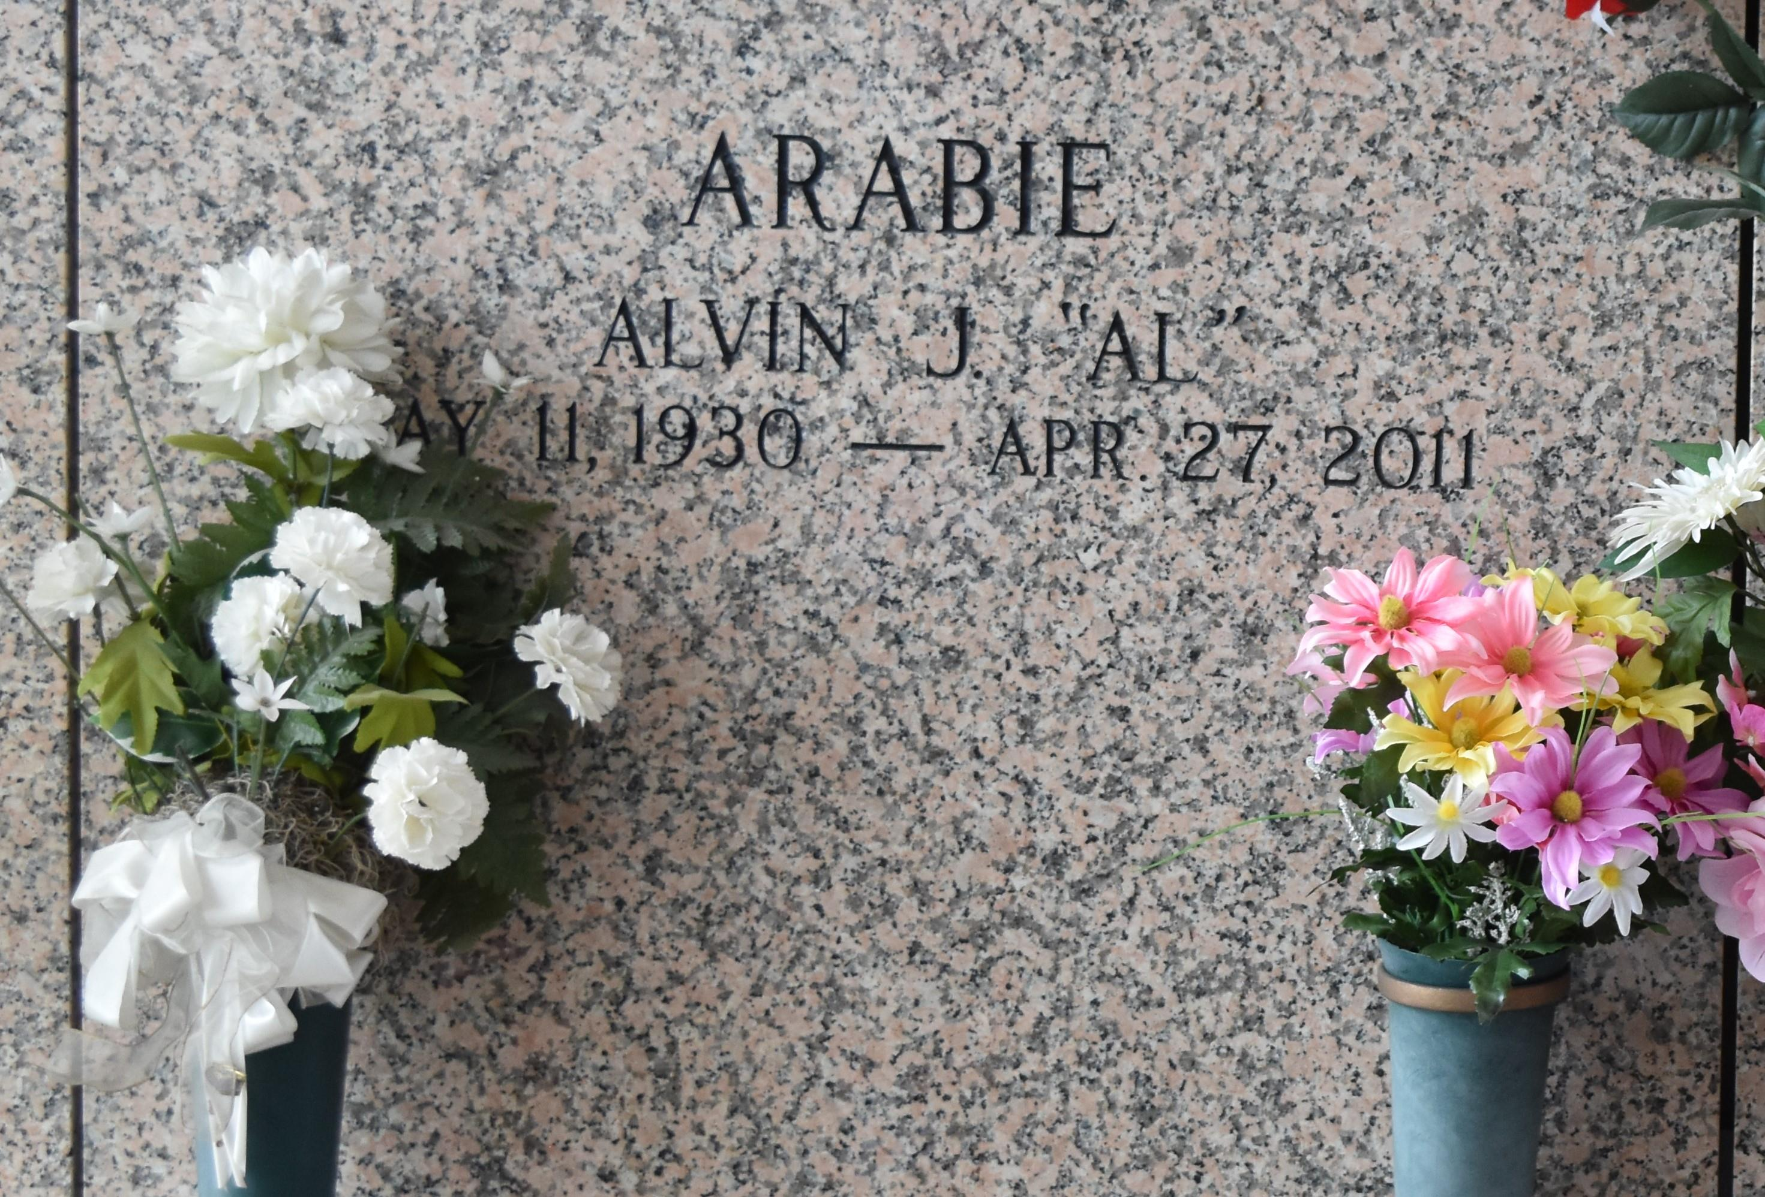

Alvin J. (Al) Arabie passed away on Wednesday April 27, 2011. Beloved father of Susan Klumpp (Johnny), Linda White (Gary) and the late Jerry Simoneaux. Also survived by 6 grandchildren and 4 great-grandchildren. Brother of Richard Arabie and Dorothy Bollinger. He was an Army Veteran of WW II. Age 80. A native of Lutcher, LA and a resident of LaPlace, LA.

Relatives and friends are invited to attend services. Visitation at St. Joan of Arc Catholic Church, 529 W. 5th St., LaPlace, LA on Saturday, April 30, 2011 from 9:00 am to 10:00 am, followed by Mass at 10:00 am. Burial in St. John Memorial Gardens Cemetery, LaPlace, LA. Arrangements by Millet-Guidry Funeral Home, LaPlace, LA.

Published by The Times-Picayune, New Orleans, Louisiana on Apr. 29, 2011.