Delton John Arceneaux

April 16, 1905 – March 6, 2009

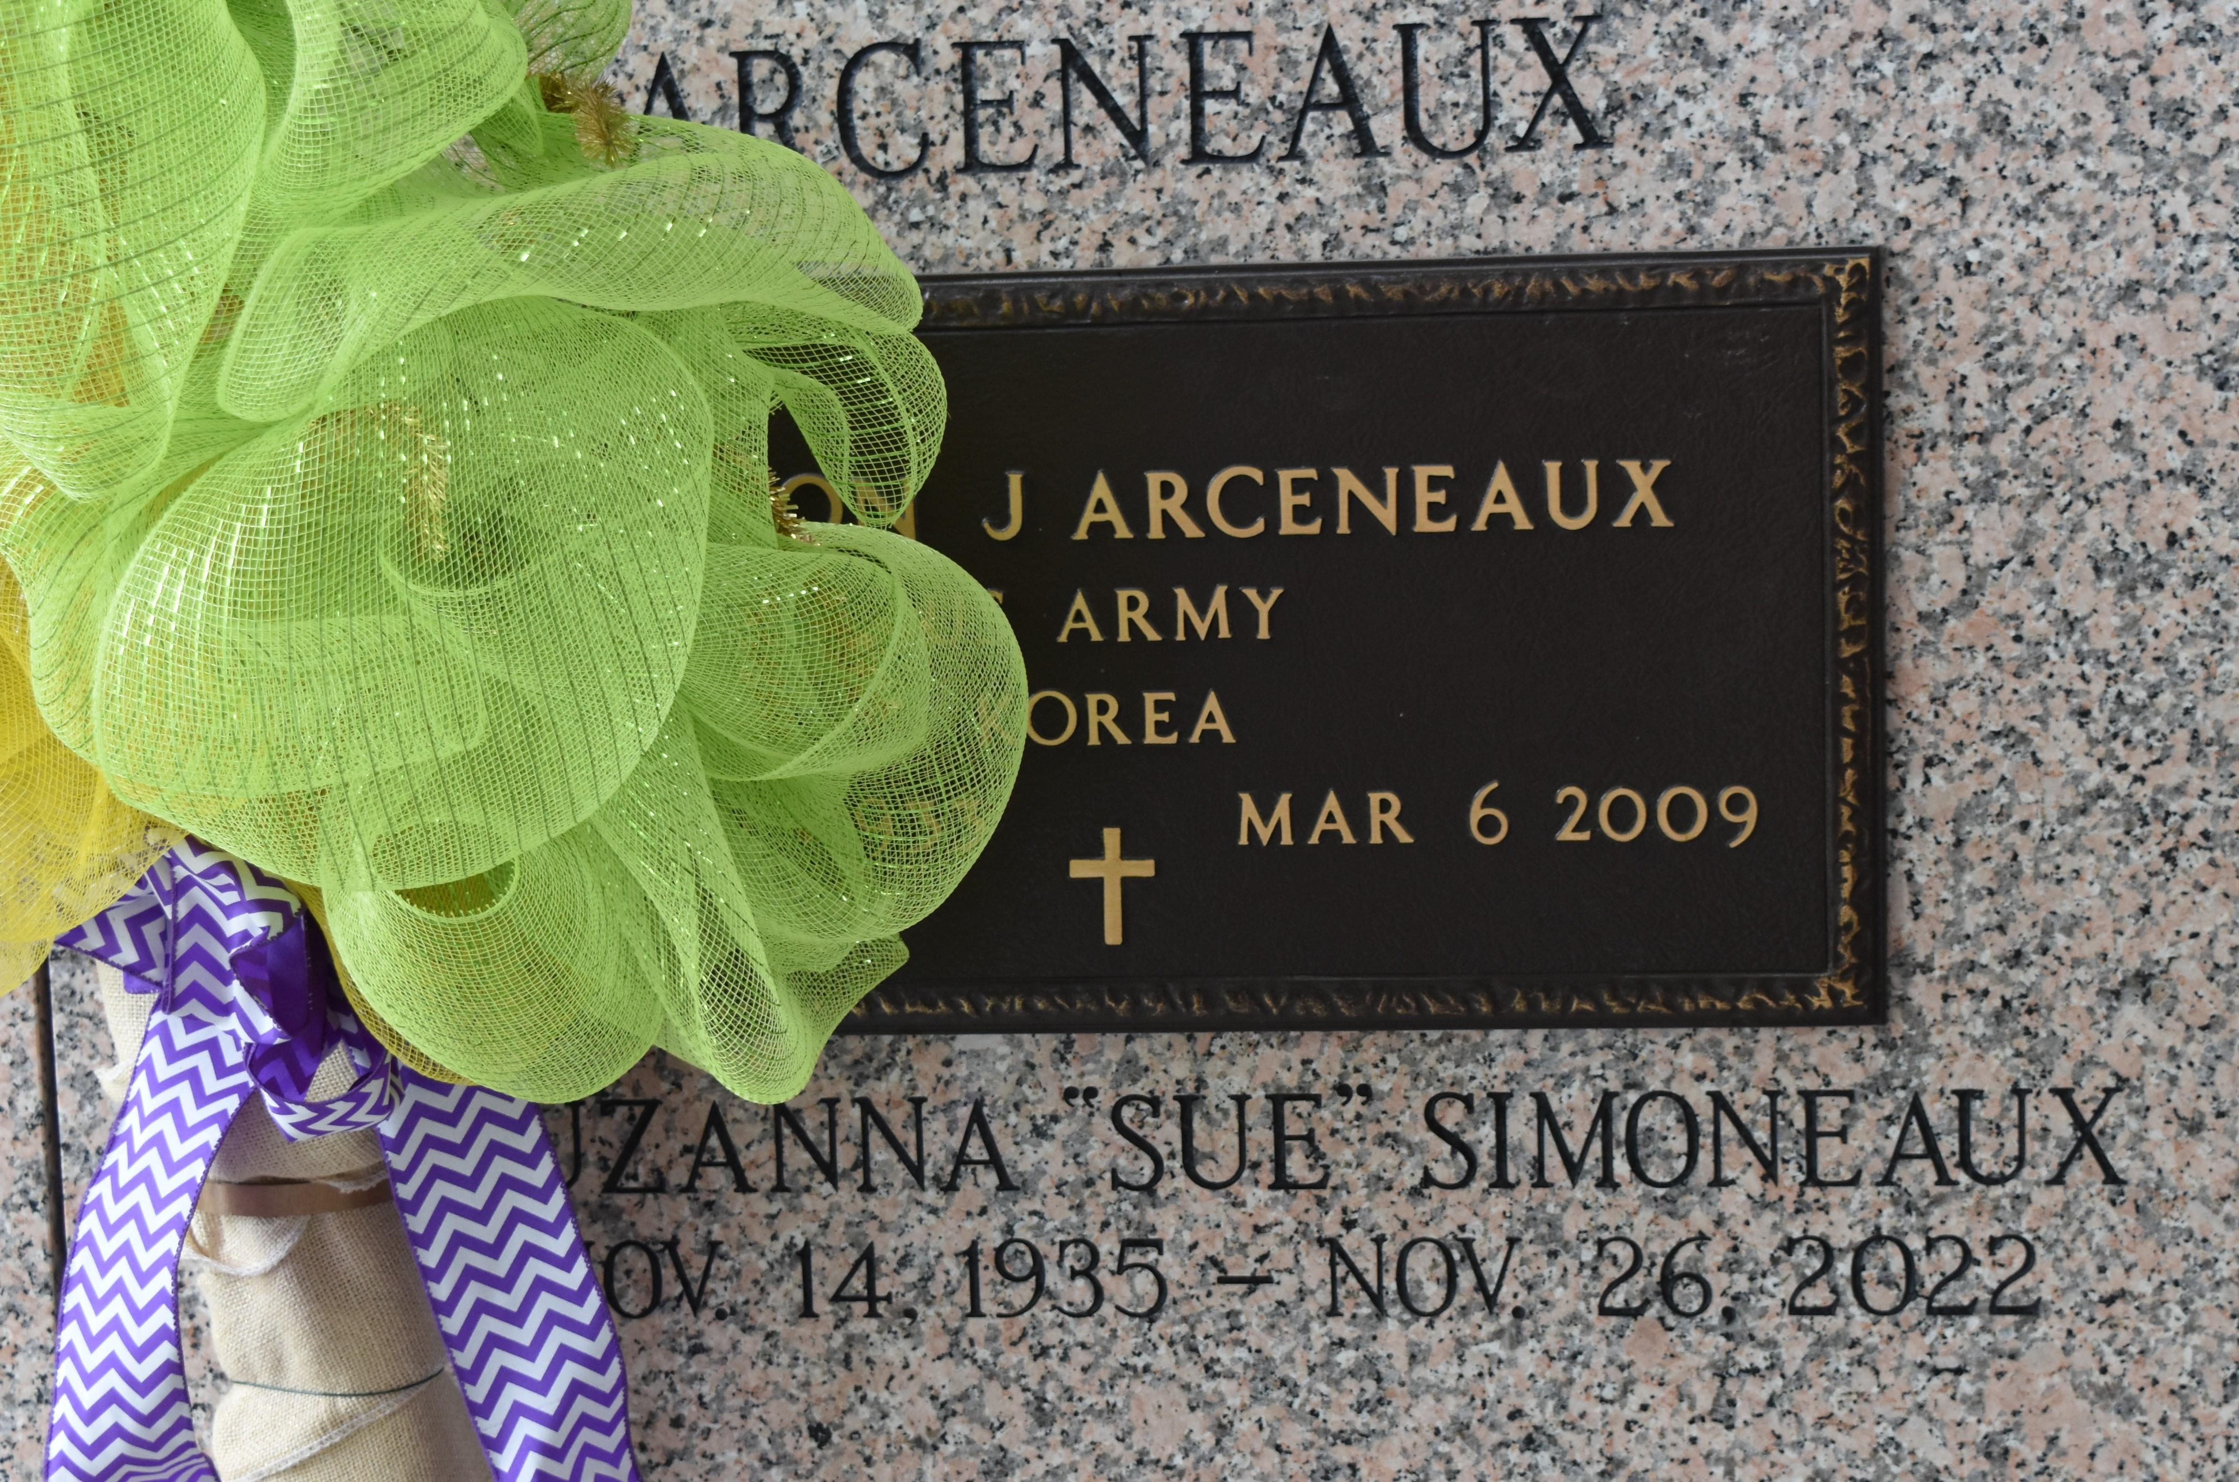

Delton John Arceneaux passed away on Friday, March 6, 2009, at 2:54 p.m. Beloved husband of Suzanna Simoneaux Arceneaux. Father of Tanya A. St. Pierre and husband Kenneth, Toni A. Clay and husband Darrin, Terri A. Braud and husband David, Ted Arceneaux, Tami A. Levatino and husband Thomas and the late Todd Arceneaux. Grandfather of Shane Arceneaux and wife April, Lindsay St. Pierre, Jenna Sonnier Braud, Kadie Levatino, Taylor Arceneaux, Ryan St. Pierre, Kalin Levatino, Trevor Arceneaux, Cole Clay, Trey Arceneaux, Callee Clay and Kaile Levatino. Son of the late Earl J. and Alta Roberts Arceneaux. He was the owner of Arceneaux Realty and retired from Dupont. Age 76. A native of Rayne and a resident of LaPlace for the past 46 years. Visitation and services were held at St. Joan of Arc Catholic Church in LaPlace on Tuesday, March 10. Burial in St. John Memorial Gardens Cemeterey in LaPlace. In lieu of flowers, donations preferred to St. Jude Hospital or The American Cancer Society.

L'Observateur (La Place, LA) - Wednesday, March 11, 2009

Contributed by Jane Edson