Angelica Asencio

January 16, 1917 – February 17, 2006

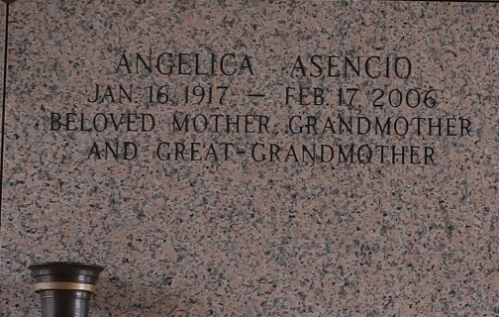

LAPLACE - Angelica Asencio, 89, a native of Puerto Rico and a resident of LaPlace, died Feb. 17. She is survived by her daughters Sandra (Jack) Fernandez and Juanita Rivera. She is also survived by her grandchildren Martin, John and Brandon Fernandez and Joedy and Stephanie Rivera and great-grandchildren Victoria and Oliveah Fernandez.

Services were held Feb. 21 at the Millet-Guidry Funeral Home Chapel, LaPlace, with interment in St. John Memorial Gardens, LaPlace.

L'Observateur (La Place, LA) - Wednesday, February 22, 2006

Contributed by Jane Edson