Matteo R. R. Avocato

March 6, 1967 – November 16, 2005

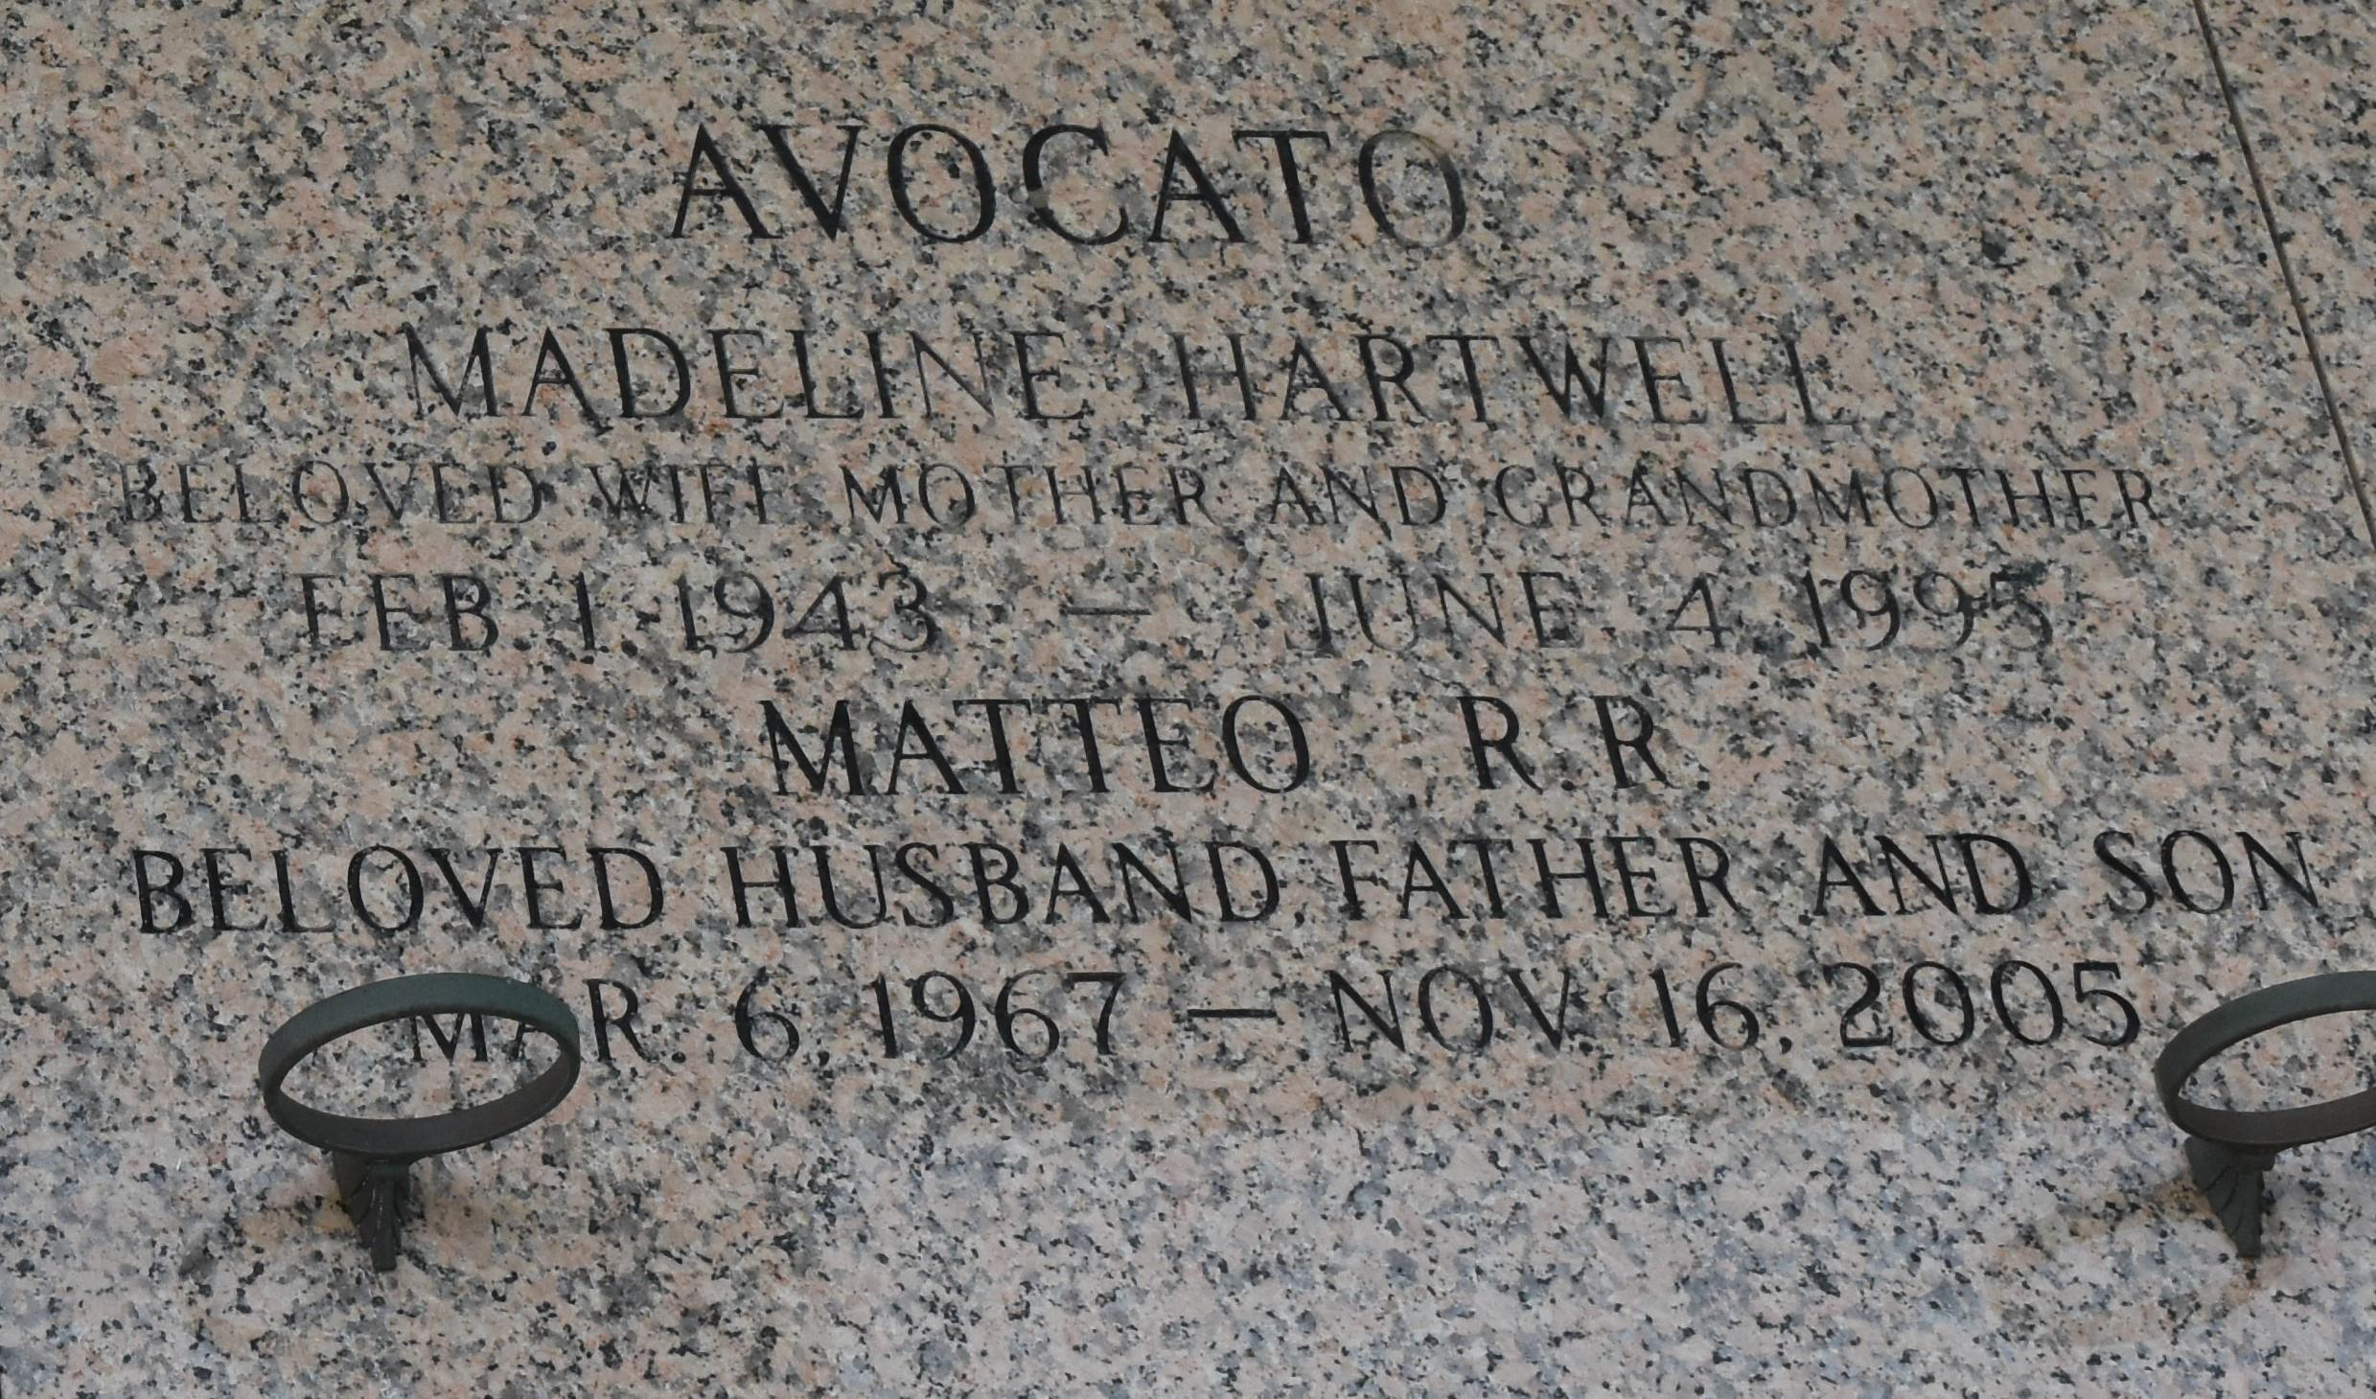

Matteo R. Avocato On Wednesday, November 16, 2005 At 12:39 A.M. Beloved Husband Of Debra Miller Avocato. Father Of Matteo R. Avocato, Ii. Son Of Matteo C. Avocato And The Late Madeline Hartwell Avocato. Step-Father Of Jessie, Marcel And Darren Miller. Age 39. A Native And Resident Of Laplace. Relatives And Friends Of The Family Are Invited To Attend Services. Visitation At Millet-Guidry Funeral Home, 2806 W. Airline Hwy., Laplace On Friday, November 18, 2005 From 5:00 P.M. Until 10:00 P.M. And On Saturday From 8:00 A.M. To 10:00 A.M. Followed By Religious Services At The Funeral Home Chapel At 10:00 A.M. Burial In St. John Memorial Gardens Cemetery, Laplace, La.

Times Picayune (LA); November 18, 2005

Contributed by SWL

\*\*\*\*\*

LAPLACE - Matteo R. Avocato, 39, native and resident of LaPlace, died Nov. 16. He was the husband of Debra Miller Avocato. He is survived by his son Matteo C. Avocato II. He is also survived by his father Matteo C. Avocato, stepchildren Jessie, Marcel and Darren Miller. He was preceded in death by his mother Madeline Hartwell Avocato. Services were held Nov. 19 at the Millet-Guidry Funeral Home Chapel, LaPlace, with interment in St. John Memorial Gardens Cemetery, LaPlace.

L'Observateur (La Place, LA) - Wednesday, November 23, 2005

Contributed by Jane Edson