Audrey Mae (Flowers) Babin
May 18, 1927 – September 4, 2014

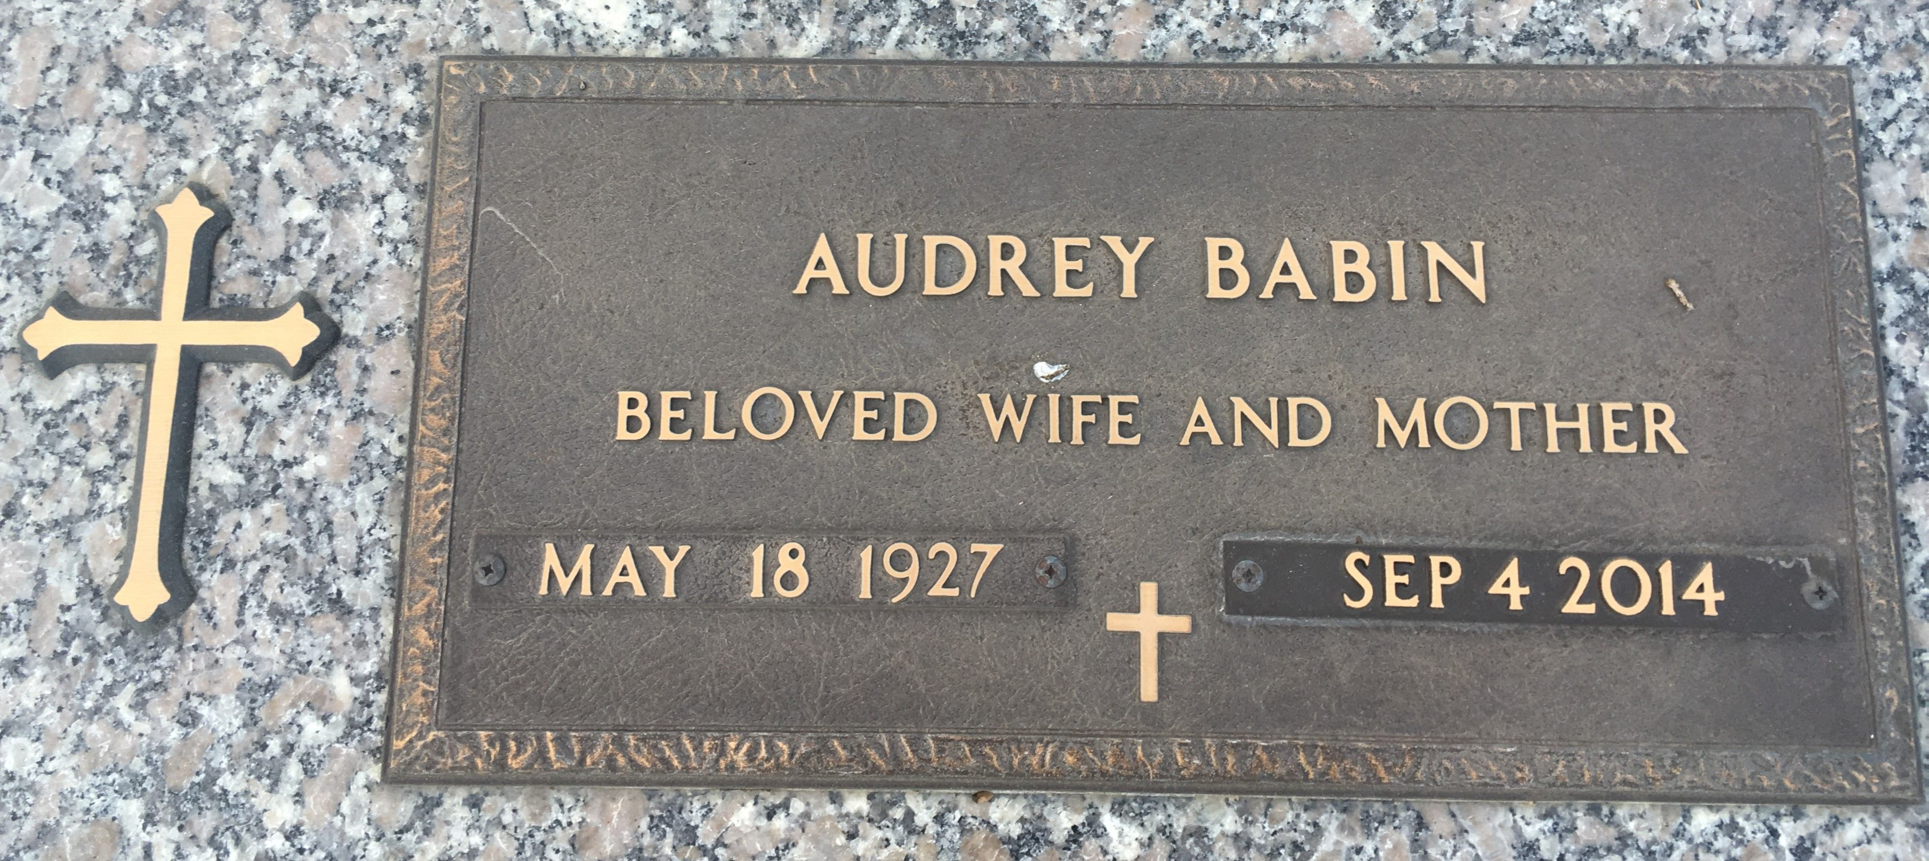

Photo by Team T-Lo

Audrey Mae Babin, 87 of Lutcher, LA passed away Thursday, September 4, 2014 at Baptist Hospital in Beaumont, TX.
Visitation will be held Sunday, September 7, 2014 from 3 - 6 p.m. at Stringer & Griffin Funeral Home in Woodville, TX. A graveside funeral service will be held Monday, September 8, 2014 at 2:00 p.m. at St. John Memorial Gardens Cemetery in LaPlace, LA. Audrey was born May 18, 1927.
She lived in Lutcher, LA until her retirement in 2006 when she moved to Tyler County. After Hurricane Rita she returned to Louisiana. She was a founding member of and attended The First Baptist Church of Gramercy, LA.
She is survived by her sons, Warren Babin & wife, Mary Audrey of Baton Rouge, LA & Larry Babin & wife, Connie of Paulina, LA; daughters, Marion Beasley of Wildwood, TX, Paula Stanley of Orange, TX & Valerie & husband, Joe Hymel of Gonzales, LA; sisters, Jean Dorrell of Colmesneil, TX, Oddie Stewart of Oklahoma, Annell Powell of Woodville, TX & Therese Kliebert of Gramercy, LA; sisters-in-law, Rose Mary Babin of Lutcher, LA & Mildred Flowers of Colmesneil, TX; 15 grandchildren & 22 great-grandchildren.
Services are under the direction of Stringer & Griffin Funeral Home of Woodville.

Advocate, The (Baton Rouge, LA)
Saturday, September 6, 2014
Contributed by Jane Edson

