Glen P. Babin

March 11, 1963 – September 7, 2011

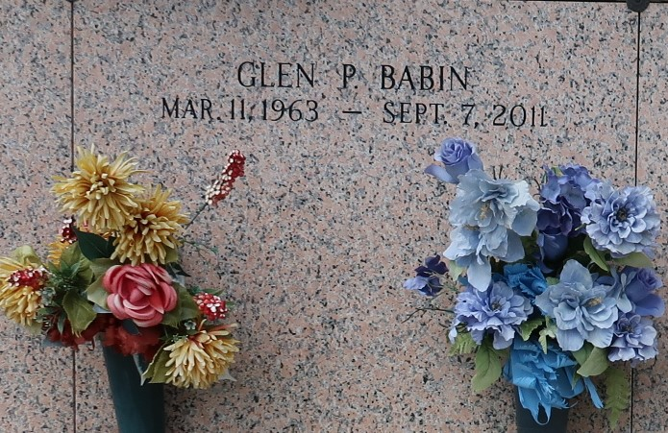

Glen Babin, 48, passed away Wednesday Sept. 7, 2011. He was the beloved father of Matthew and Marcus Babin, son of Mary Ruth St. Martin Babin and the late Norman Babin and brother of Darlene Tarullo, Wayne Mabile, Terry Mabile and the late Diane Mabile. He was a native and resident of LaPlace.

Relatives and friends are invited to attend services. Visitation will be held at Millet-Guidry Funeral Home, 2806 W. Airline Highway, LaPlace, on Saturday, Sept. 10, from 8 a.m. to 9:30 a.m., followed by Mass at St. Joan of Arc Catholic Church in LaPlace at 10 a.m. Burial will follow in St. John Memorial Gardens Cemetery in LaPlace.

L'Observateur, LaPlace, Louisiana

Saturday, September 10, 2011