Oscar J. Babin, Jr.

March 21, 1941 – November 9, 2004

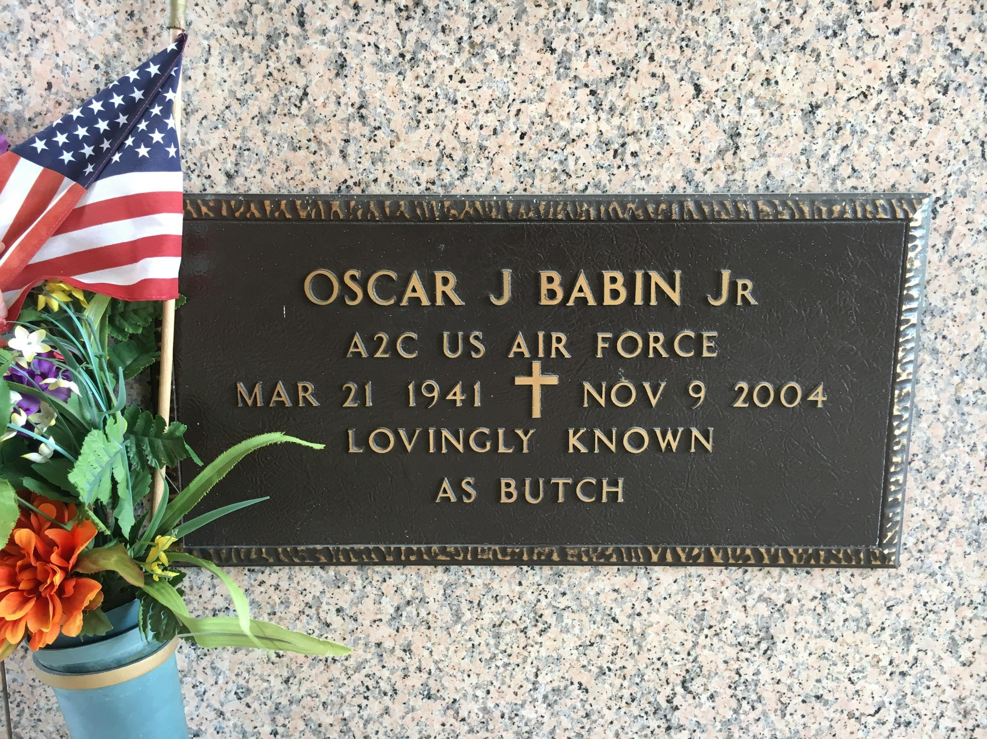

Oscar (Butch) (Oj) Babin, Jr. On Tuesday, November 9, 2004 At 3:20 Pm. Beloved Husband Of Sylvia Vilemont Babin. Father Of Angie Babin Cambre. Grandfather Of Toni And Dalton Cambre. Son Of The Late Oscar Sr. And Lydie Brignac Babin. Age 63. A Native And Resident Of Laplace.

Relatives And Friends Of The Family Are Invited To Attend Services. Visitation At Millet-Guidry Funeral Home, 2806 W. Airline Hwy., Laplace, On Thursday, November 11, 2004 From 5:00 Pm To 10:00 Pm And On Friday From 11:00 Am To 12:45 Pm. Followed By Religious Services At St. Joan Of Arc Catholic Church, Laplace At 1:00 Pm. Burial In St. John Memorial Gardens Cemetery, Laplace.

Times Picayune, New Orleans, Louisiana

November 11, 2004