Sandra (King) Bandsma

Abt. 1938 – October 14, 2012

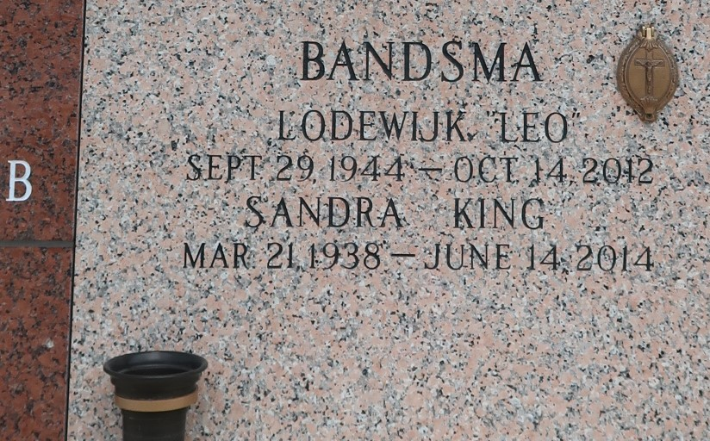

Sandra King Bandsma passed away on Saturday, June 14, 2014. Beloved wife of the late Lodewijk (Leo) Bandsma. Mother of Kristina Bandsma Miller and Elisa Bandsma Chapman (Stephen). Nana of Alex and Andrew Miller, Jack, Thomas and Katherine Chapman. Daughter of the late Arthur and Augustine King. Sandra was a woman of great faith, who found comfort praying her daily rosary. Her happiest days were those spent with her family and grandchildren, and her dear companion, her cat, Caty. She retired from St. Charles Catholic High School after many years of service. Age 76. A native of Algiers, LA and a resident of LaPlace, LA.

Relatives and friends are invited to attend services. Visitation at Ascension of Our Lord Catholic Church, 1809 Greenwood, LaPlace, LA on Tuesday, June 17, 2014 from 9:00am to 12:00pm, followed by Mass at 12:00 noon. Burial in St. John Memorial Gardens, LaPlace, LA. Heartfelt thanks to her caregivers, Angela Anderson, Gloria Alexander, Kushmala Murphy and Robin Bourgeois. In lieu of flowers Masses preferred. Arrangements by Millet-Guidry Funeral Home, LaPlace, LA.

Times-Picayune, The (New Orleans, LA)

Sunday, June 15, 2014