Ida Mae (Zeringue) Barre

February 4, 1919 – September 6, 2003

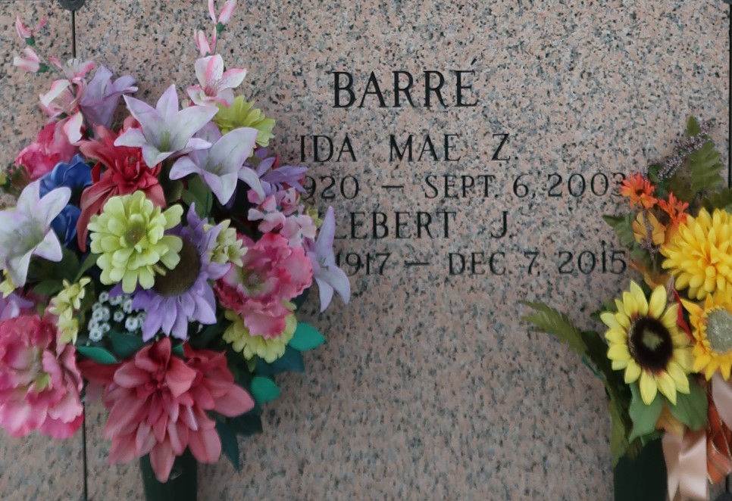

Ida Zeringue Barre' on Saturday, September 6, 2003 at 5:45 A.M. Beloved wife of Klebert Barre'. Mother of Wendy B. Howes of Reserve, La., Farrel Barre' of Statesville, N.C., Carrol B. Duhe of Reserve, La. and Don J. Barre' of Kenner, La. Daughter of the late Sidney and Maria Braud Zeringue. Sister of Noelie Roussel, Earline Weber, Lillian Audiffred and Eliza Oubre. Also survived by 10 grandchildren and 10 great grandchildren. Age 83. A native of Gramercy, La. and a resident of Reserve, La. for the past 65 years. Relatives and friends of the family are invited to attend services. Visitation at St. Peter Catholic Church, Reserve, La. on Monday, September 8, 2003 from 12 Noon until 2 P.M. Followed by religious services at St. Peter Catholic Church at 2 P.M. Burial in St. John Memorial Gardens Cemetery, Laplace, La. In lieu of flowers donations preferred to the Msgr. Eyraud Sainthood Fund, P.O. Box 435, Reserve, La. 70084. Arrangements by Millet-Guidry Funeral Home, Laplace, La.

Times-Picayune, The (New Orleans, LA)

Sunday, September 7, 2003