Rev. Father Dennis Bergeron

November 27, 1919 – February 14, 1989

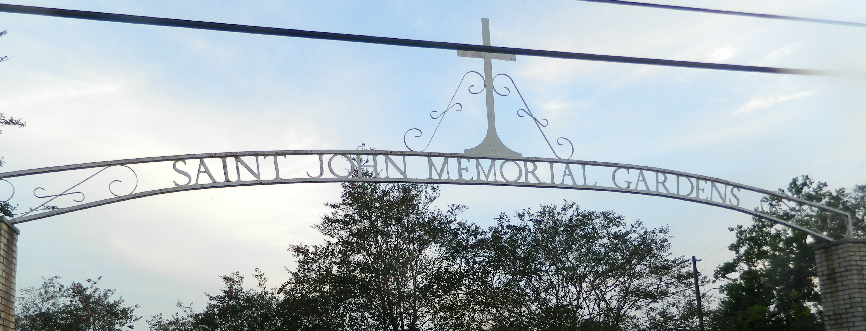

Members of St. Joan of Arc Catholic Church in LaPlace will bid farewell Friday to their longtime pastor, Monsignor Dennis "Pete" Bergeron, who died Tuesday in New Orleans. Bergeron died of a heart attack while walking to St. Louis Cathedral Tuesday to attend installation services for Archbishop Francis B. Schulte. Bergeron was 69.  
 Schulte will conduct the funeral service Friday at 11 a.m. at the church on West Fifth Street. He will be assisted by retired Archbishop Philip Hannan and priests of the Archdiocese of New Orleans.  
 Monsignor John M. Weber of the Church of St. Charles Borromeo in Baton Rouge will deliver the homily at the Mass. Burial will be at St. John Memorial Gardens in LaPlace.  
 Bergeron had been pastor at St. Joan of Arc for more than 25 years. Born in Port Allen, La., in 1919, Bergeron entered St. Joseph Abbey near Covington at age 11. He attended Notre Dame Seminary in New Orleans and was ordained in 1945. He was assistant pastor at Sacred Heart Church in Cut Off, La., and St. James Major Church in New Orleans, and pastor of St. Hubert Church in Garyville and St. Bridget Church in Schriever, La., before arriving at St. Joan in LaPlace in 1963.  
 Sister Mary Germaine, principal of St. Joan of Arc School in LaPlace, said Bergeron will long be remembered for the way he cared for others. "His greatest legacy would be love of children, attentive to those in need and a father figure to us all," she said.  
 LaPlace resident Juliette Maquar said the St. Joan of Arc Ladies Altar Society will miss him greatly. "I just lost one of my best friends," Maquar said. "He was so good to everyone. He was such a down-to-earth person."  
 Bergeron was chaplain for the Knights of Columbus Council 5935 and for the local court of Catholic Daughters of the Americas, the largest lay Catholic women's group in the United States.  
 Bergeron was active in the St. Vincent de Paul Society. He was the deanery director for the Family Life Bureau of the Archdiocese of New Orleans.  
 The Rev. Gerald Hindman of St. Joseph's Abbey has been a friend of Bergeron since 1937. They were classmates at St. Joseph's Seminary. Hindman said Bergeron was a self-sacrificing priest and a completely dedicated friend. "He was totally dedicated to his priesthood ministry. He gave zealous attention to his duties as pastor," Hindman said. "The needs of his people were his paramount concern. And once you were his friend, you were his friend forever."

Times Picayune, New Orleans, Louisiana

Friday, February 17, 1989, page B-3