Douglas C. Black

1928 – February 9, 2023

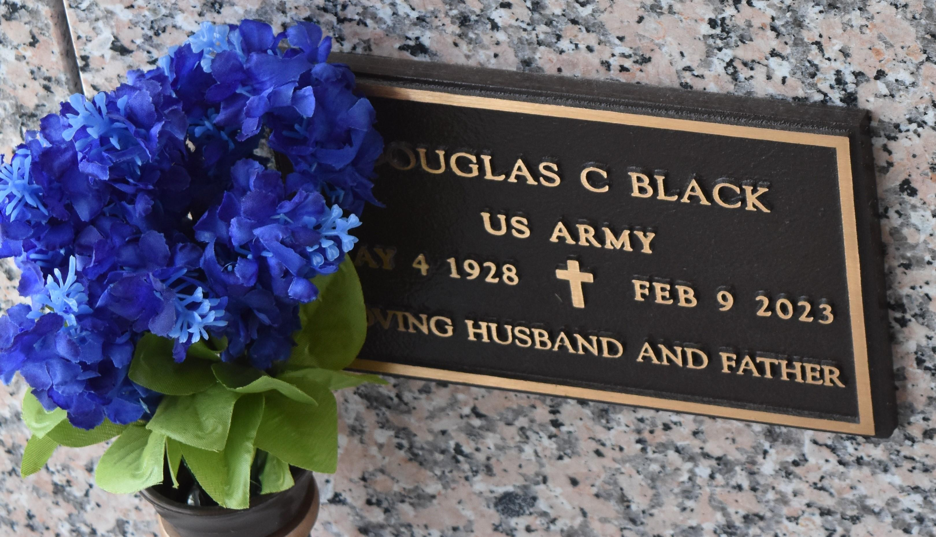

Douglas C. Black passed away on Thursday, February 9, 2023 at the age of 94. He was a native of Baltimore, MD and a resident of LaPlace, LA. Beloved husband of Mary “Beth” Abadie Black. Loving father of Pamela Cambre (Don), Heidi Landry (Sandy), Mary Lecander (Don) and Patricia Dill (Stan). Grandfather of Kaley Landry Frederick (Josh), Jessie Landry Percle (Norman), Dustin Lecander, Aric Lecander (Rochelle), Suzanne Lecander Huff (Rob), Amanda Lecander Lewis (Scott), Tracey Lecander Scott (Jeff), April Dill, Aaron Dill (Emily), Adam Dill (Gretchen)and Amber Dill Humm (Brian). Also survived by 16 great-grandchildren. Son of the late Mabel Hackney Black and Edmund Kenneth Black. Brother of the late Jack Black, Alan Black, Frances Black Earley, Norman Black, Margery Black Herman and Richard Black. Proudly served in the U.S. Army for 20 years before he retired. He then worked for 27 years with the U.S. Postal Service, where he was best known as Mr. Zip.

L’Observateur, LaPlace, Louisiana

February 10, 2023