Randal J. Bostaff

February 14, 1966 – September 5, 2002

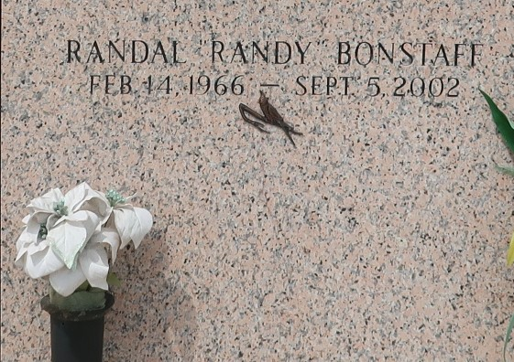

LAPLACE - Randal "Randy" Bonstaff, 36, a native of Pineville and resident of Muskogee, Okla., died Sept. 5. He was the son of Cheryl Mitchell and Jack Bonstaff, stepson of Joe Mitchell and Cathy Bonstaff, and brother of Rhonda Dorman, Renee, Rochelle and Jennifer Bonstaff. He was the grandchild of Ella Dean Bonstaff.

Services were Sept. 9 in the chapel of Millet-Guidry Funeral Home, LaPlace, with interment at St. John Memorial Gardens, LaPlace.

L'Observateur, LaPlace, Louisiana

Friday, September 13, 2002