Eunice (Parfait) Borne

October 28, 1928 – August 2, 2010

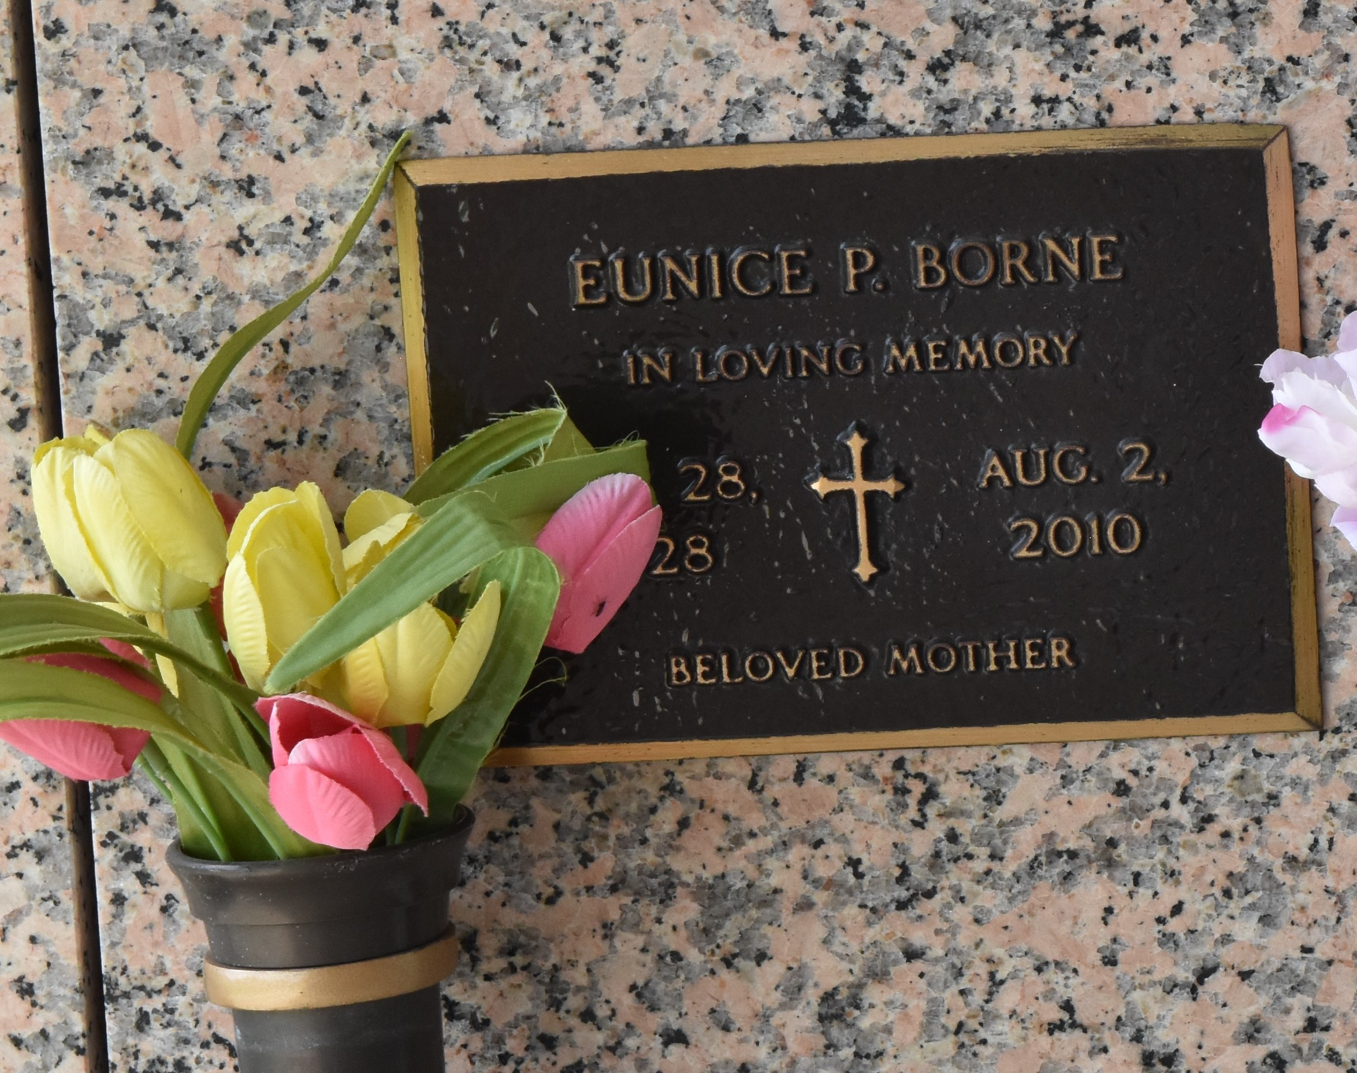

Eunice Parfait Borne departed this earthly life on Monday, August 2, 2010 at her daughter's residence in Laplace, LA. Wife of the late Paul Andrew Borne. Beloved mother of Mary Borne Fraisse and Karen Borne Wylie of Laplace, LA. Grandmother of Kevin Andrew Bennett. Sister of Mary Ellen Parfait. Also survived by a host of nieces, nephews, other relatives and friends. Relatives and friends of the family are invited to attend the Funeral Mass at Bardell's Mortuary, 3856 Hwy. 44, Mt. Airy, LA, on Thursday, August 5, 2010 at 10:00 A.M. Visitation at 9:00 A.M. Bardell's Mortuary of Mt. Airy, LA in charge. Information: 985-535-6837

The Times-Picayune, New Orleans, Louisiana

August 4, 2010.