Lester Bornes Jr.

June 24, 1992 – February 17, 2019

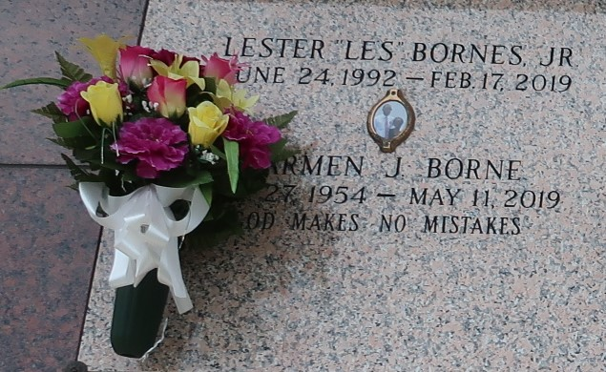

Lester "Les" Bornes, Jr, age 26, departed this life on Sunday, February 17, 2019. Son of Carmen and Lester Bornes Sr. Brother of Kiara Shavers, Denise and Shenita McBride, Devin and Tevin Bornes. Les is survived by a host of nephews, nieces, aunts, uncles, other relatives and friends.

Celebration service will be held on Thursday, February 28, 2019 at 10:00am at Milesville Memorial COGIC 129 apple St, LaPlace, LA 70068. Bishop Ronald Frank Pastor officiating. Viewing from 8:00am until service time. Internment St. John Memorial Laplace, La. Professional Services entrusted to the caring staff Hobson Brown Funeral Home, 134 Daisy St., Garyville, La 70051, (985) 535-2516.

The New Orleans Advocate, Louisiana

Feb. 26 to Feb. 28, 2019