Roger Bossier

October 10, 1945 – February 14, 2003

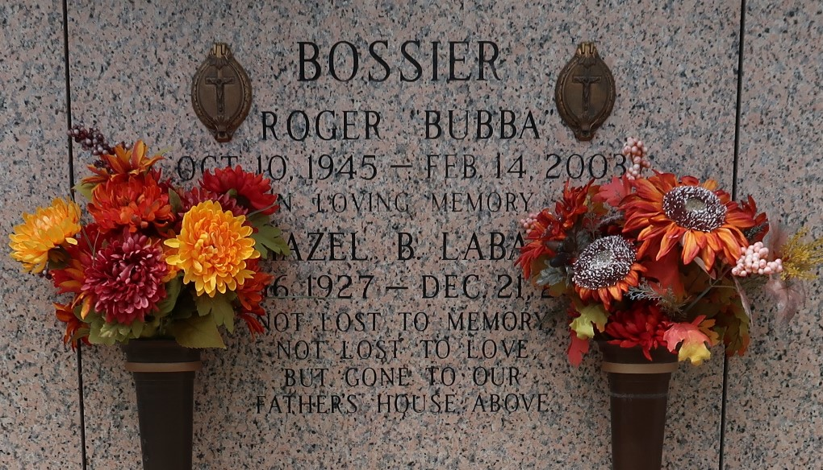

Roger 'Bubba" Bossier on Friday, February 14, 2003 at 7:25 AM. Beloved husband of Betty Cain Bossier. Father of Samantha Reed, Vanessa Lowry, Roger III, Roger IV and Kenny Bossier and Lee Lee Gaudet, adopted father of Anita Breaux. Son of Hazel Labat and the late Roger Bossier. Brother of Rena and Cecile Webre, Rose Laiche, Mona Hogsett, Juanita and Danny Bossier also survived by 12 grandchildren and 1 great-grandchild. Age 57 years. A native of New Orleans, LA and a resident of Laplace, LA for the past 57 years. Relatives and friends of the family are invited to attend services. Visitation at Millet Guidry Funeral Home, 2806 W. Airline Hwy., Laplace, LA. on Monday, February 17, 2003 from 10: 00 AM to 12:00 PM followed by Religious Services in funeral home chapel at 12:00 PM. Burial in St. John Memorial Garden, Laplace, La.

Times-Picayune, The (New Orleans, LA) — Sunday, February 16, 2003 Contributed by Jane Edson