Rebecca “Becky” (Clause) Boudreaux

Abt. 1942 – February 10, 2001

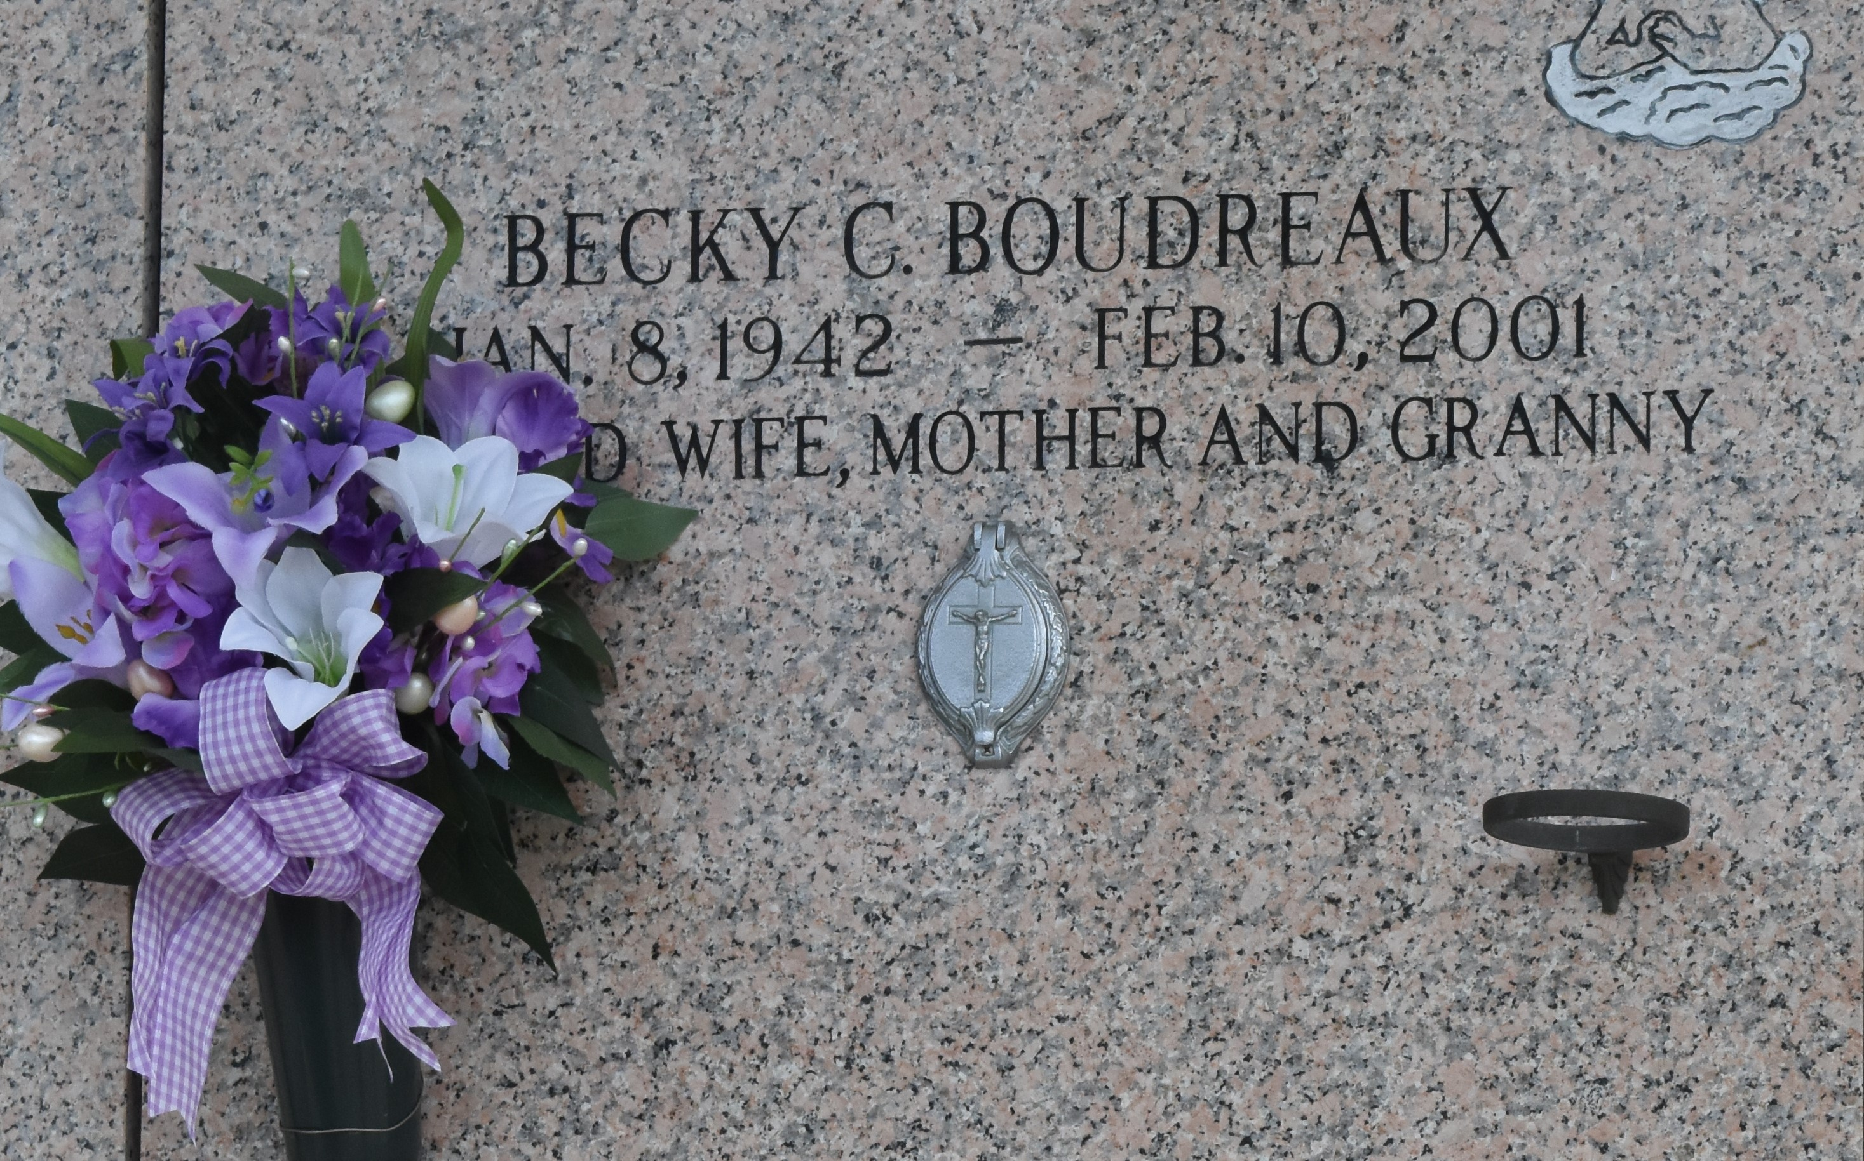

LAPLACE - Rebecca Clause "Becky" Boudreaux, 59, a native of Klotzville and resident of LaPlace for 35 years, died Feb. 10. She was the wife of Lawrence "Larry" Boudreaux and mother of Renee, Angelle and Scott Boudreaux. She was also the daughter of the late Claude and Rita Young Clause and sister of Claudia Aucoin and Beverly Blanchard. She is also survived by two grandchildren. Services were Feb. 13 at St. Joan of Arc Catholic Church, LaPlace, with interment at St. John Memorial Gardens, LaPlace.

L'Observateur, LaPlace, LA; February 14, 2001

\*\*\*\*\*

A homemaker and a resident of LaPlace for 35 years, she died at 4:40 a.m. Saturday, Feb. 10, 2001, at her home. She was 59 and a native of Klotzville.

Visiting at Millet-Guidry Funeral Home, 2806 W. Airline Highway, LaPlace, from 5 p.m. to 9 p.m. Monday. Visiting at the funeral home from 8 a.m. to 9:30 a.m. Tuesday. Mass of Christian Burial at St. Joan of Arc Catholic Church, LaPlace, at 10 a.m. Tuesday. Interment in St. John Memorial Gardens, LaPlace.

She was the beloved wife of Lawrence "Larry" Boudreaux; mother of Scott, Angelle and Renee Boudreaux; mother-in-law of Pam Boudreaux; grandmother of Shane and Patrick Boudreaux; daughter of the late Claude and Rita Young Clause; and sister of Claudia Aucoin and Beverly Blanchard, both of Napoleonville.

Advocate, The (Baton Rouge, LA) - Sunday, February 11, 2001

Contributed by Jane Edson