Hubert Joseph Bourgeois Sr.

July 26, 1929 – September 7, 2012

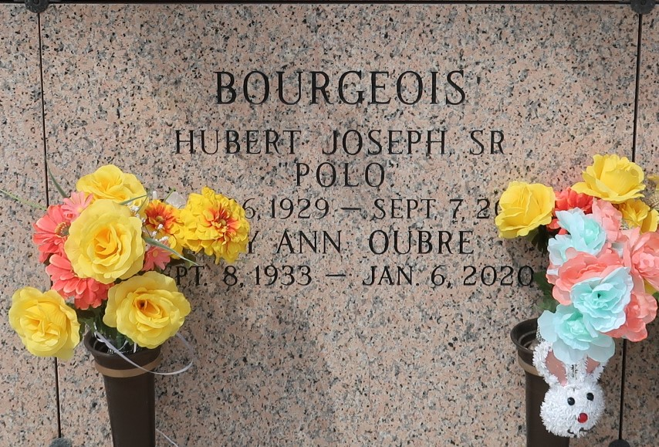

Hubert Bourgeois, 83, of St. Charles Garyville, man dies in crash on Airline An 83-year-old passenger in a GMC Envoy died Friday when the SUV collided with a van in St. Charles Parish. Hubert Bourgeois of Garyville died at the scene. Bourgeois was the front passenger in the vehicle driven by Elizabeth Hebert, 54, of LaPlace, according to State Police, who investigated the crash on Airline Drive at East Harding Street. Trooper Melissa Matey said Hebert lost control of the Envoy about 2:30 p.m. "for unknown reasons" while traveling north on Airline. The Envoy "rotated and crossed the median into the southbound lanes," Matey said. The SUV then was struck by a 2000 Chevrolet Express driven by Erickson Pelletier, 20, of New Mexico. Hebert was transported to a hospital in critical condition. Pelletier and two passengers in the van were transported to Ochsner Kenner Medical Center with moderate injuries, Matey said. Toxicology results are pending for Hebert and Pelletier, according to State Police. Bourgeois was not wearing a seat belt, Matey said. "The crash remains under investigation," she said, "and charges are pending."

Times-Picayune, The (New Orleans, LA)

Saturday, September 8, 2012

\*\*\*\*\*

Hubert Bourgeois Sr. passed away on September 7, 2012 at the age of 83. Relatives and friends are invited to attend a visitation at H.C. Alexander Funeral Home in Lutcher on Tuesday, September 11, 2012 from 6-9 PM. There will be a visitation at St. Hubert's Church in Garyville on Wednesday September 12, 2012 starting at 9 AM followed by a Funeral Mass at 11 AM. Interment will follow at St. John's Memorial Garden.

Times-Picayune, The (New Orleans, LA)

Tuesday, September 11, 2012

Both contributed by Jane Edson