Johnny Leroy Boynton Jr.

November 15, 1975 – December 2, 2005

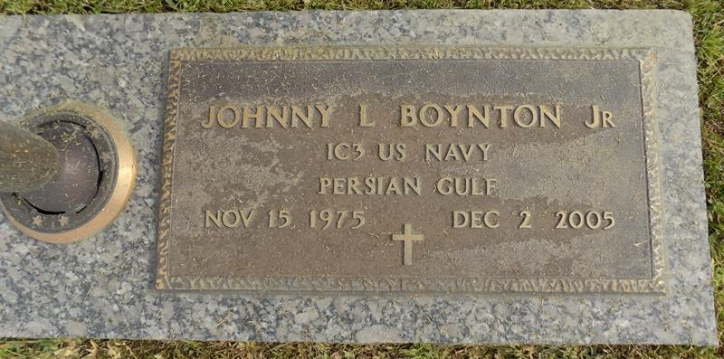

GARYVILLE - Johnny Leroy Boynton Jr., 30, a native and resident of Garyville, died Dec. 2. He was the husband of Summer LeBouf Boynton. He is survived by his children Logan and Jude Boynton. He is also survived by his parents Mary Kay Brady and John Boynton Sr., grandmothers Gertrude Brady Walker and June Boynton and siblings Cassie Herbert and Heaven Boynton.

Services were held Dec. 6 at Rose Lynn Funeral Services Chapel, Lutcher, with interment in St. John Memorial Garden, LaPlace.

L'Observateur, LaPlace, Louisiana

Wednesday, December 7, 2005

Contributed by Jane Edson