Patricia Diane (Covington) Branton

July 1948 – February 2, 2020

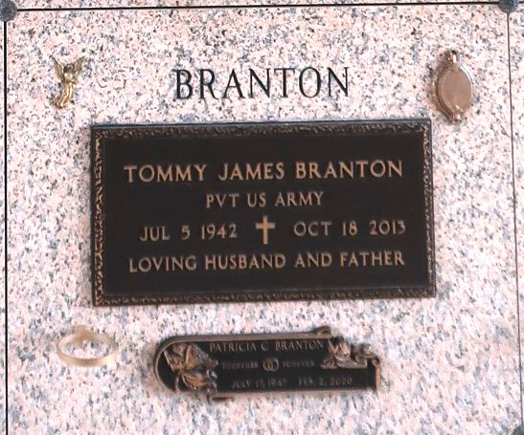

Patricia Diane Covington Branton passed away on Sunday, February 2, 2020 at the age of 72. She was a resident of Albany, LA; native of Laplace, LA. She is survived by children, Tommy (Louise), Daryl (Brenda), Curtis (Christie) Hanna, Tommy Branton Sr. (Cherlyn); and brother Michael (Mary) Covington. She is also survived by a host of grandchildren, great grandchildren, neices and nephews.

She is preceded in death by her father Daniel E. Covington; step-father Willie Decota; mother Mary Alice Efferson Decota; husband Tommy Branton; a son "Little" Herman Hanna; daughter Pamela Anderson; brothers Carl and Jimmy Covington.

Funeral Services to be held on Friday, February 7th at The Baloney Funeral Home, LLC located at 1905 W Airline Hwy, Laplace, LA. Viewing from 10:00 AM-12 PM, service immediately following. Interment will be at St. John Memorial Gardens Cemetery, 2205 W. Airline Hwy.,Laplace, LA. Funeral arrangements entrusted to The Baloney Funeral Home, LLC. 1905 W. Airline Highway, LaPlace, LA. 70068, (985) 224-8460.

The Times-Picayune, New Orleans, Louisiana

Feb. 5 to Feb. 7, 2020