Helen M. (Arostegui) Brayard

January 8, 1931 – October 16, 2020

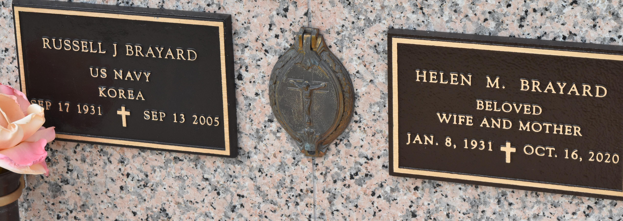

## January 8, 1931 - October 16, 2020

Helen Arostegui Brayard passed away on Thursday, October 16, 2020. Helen resided in LaPlace, LA from 1965 to the present.  
 She was preceded in death by her husband of 52 years, Russel J. Brayard (1931-2005). Helen is survived by her son and his family, Mark Brayard, his wife Arlene and their son, Stephen Brayard; her son Richard Brayard, his wife Kristen and their children, Aubry and Ashton; and her son, Robert Brayard, his wife Shannon and their children Tiffany, Haley and Madison and her great granddaughter Reiley. She is also survived by her sister, Bessie Theobold. She is loved and will be missed.

Millet-Guidry Funeral Home, LaPlace, Louisiana