Robert J. Brennan Jr.

March 14, 1934 – Febraury 19, 2003

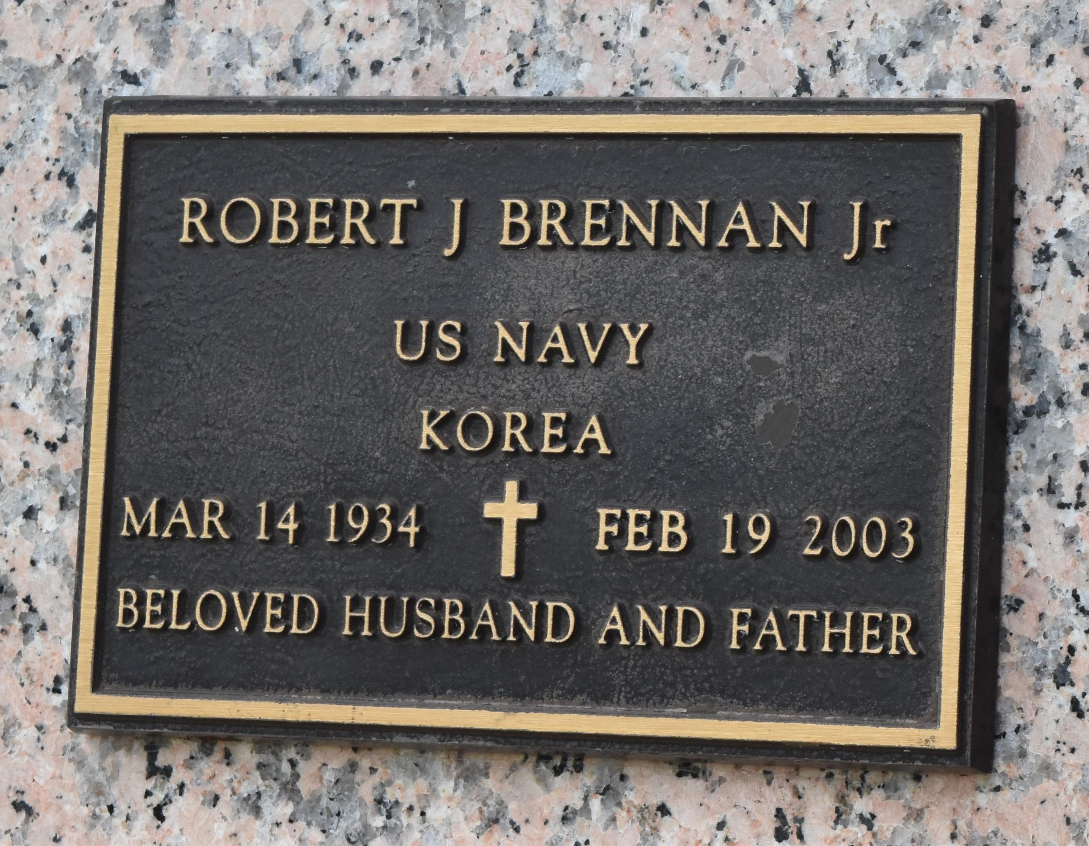

Robert J. Brennan, Jr. on Wednesday, February 19, 2003 at 1:00 p.m. Beloved husband of Lorraine Fagot Brennan. Father of Robert J. Brennan and Colleen B. Owens. Son of the late Robert and Rosetta Brennan. Brother of Jayne Vildibill. Grandfather of Jimmy, Ashley, Whitney, Alex and Abbey. Age 68. A native of New Orleans, past resident of LaPlace and a resident of Ponchatoula for the past 6 years. Relatives and friends of the family are invited to attend services. Visitation at Millet-Guidry Funeral Home, 2806 W. Airline Hwy., LaPlace on Friday, February 21, 2003 from 5:00 p.m. to 9:00 p.m. and on Saturday from 9:00 a.m. to 9:45 a.m. Followed by religious services at St. Joan Arch Catholic Church, Laplace at 10:00 a.m. Private burial to be held at later date. In lieu of flowers donations to Hospice preferred.

The Times-Picayune, New Orleans, Louisiana

Feb. 21, 2003.