Earl A. Brennecke

August 25, 1930 – February 21, 2001

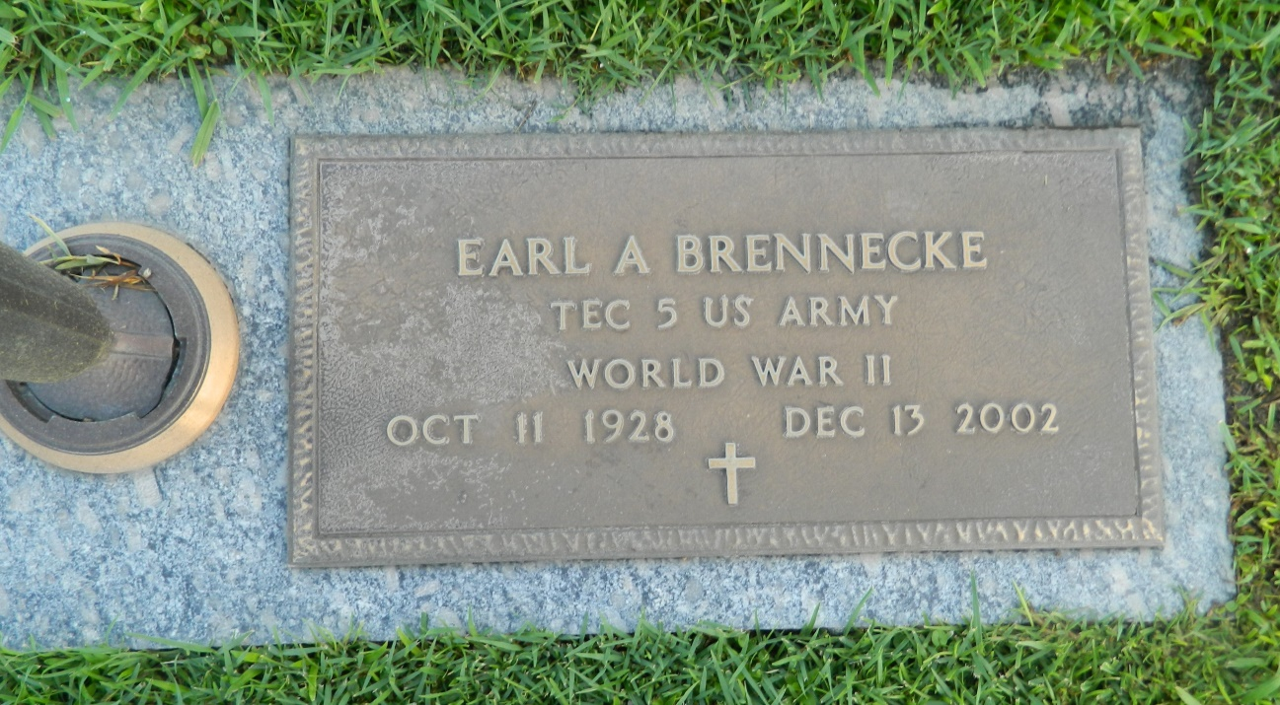

LAPLACE - Earl Brennecke, 74, a native of Missouri and resident of LaPlace for 24 years, died Dec. 13. He was the husband of the late Bernie Brennecke and father of Susan Landon and Robert, Carl and Larry Brennecke. He was the brother of Gene Meinders and Judy Muier. He is survived by four grandchildren and was preceded in death by one grandchild. Services were Dec. 16 in the chapel of Millet-Guidry Funeral Home, LaPlace, with interment at St. John Memorial Gardens, LaPlace.

L'Observateur, LaPlace, Louisiana

Friday, December 20, 2002

Contributed by Jane Edson