Antoine J. Brignac

September 11, 1927 – October 17, 2013

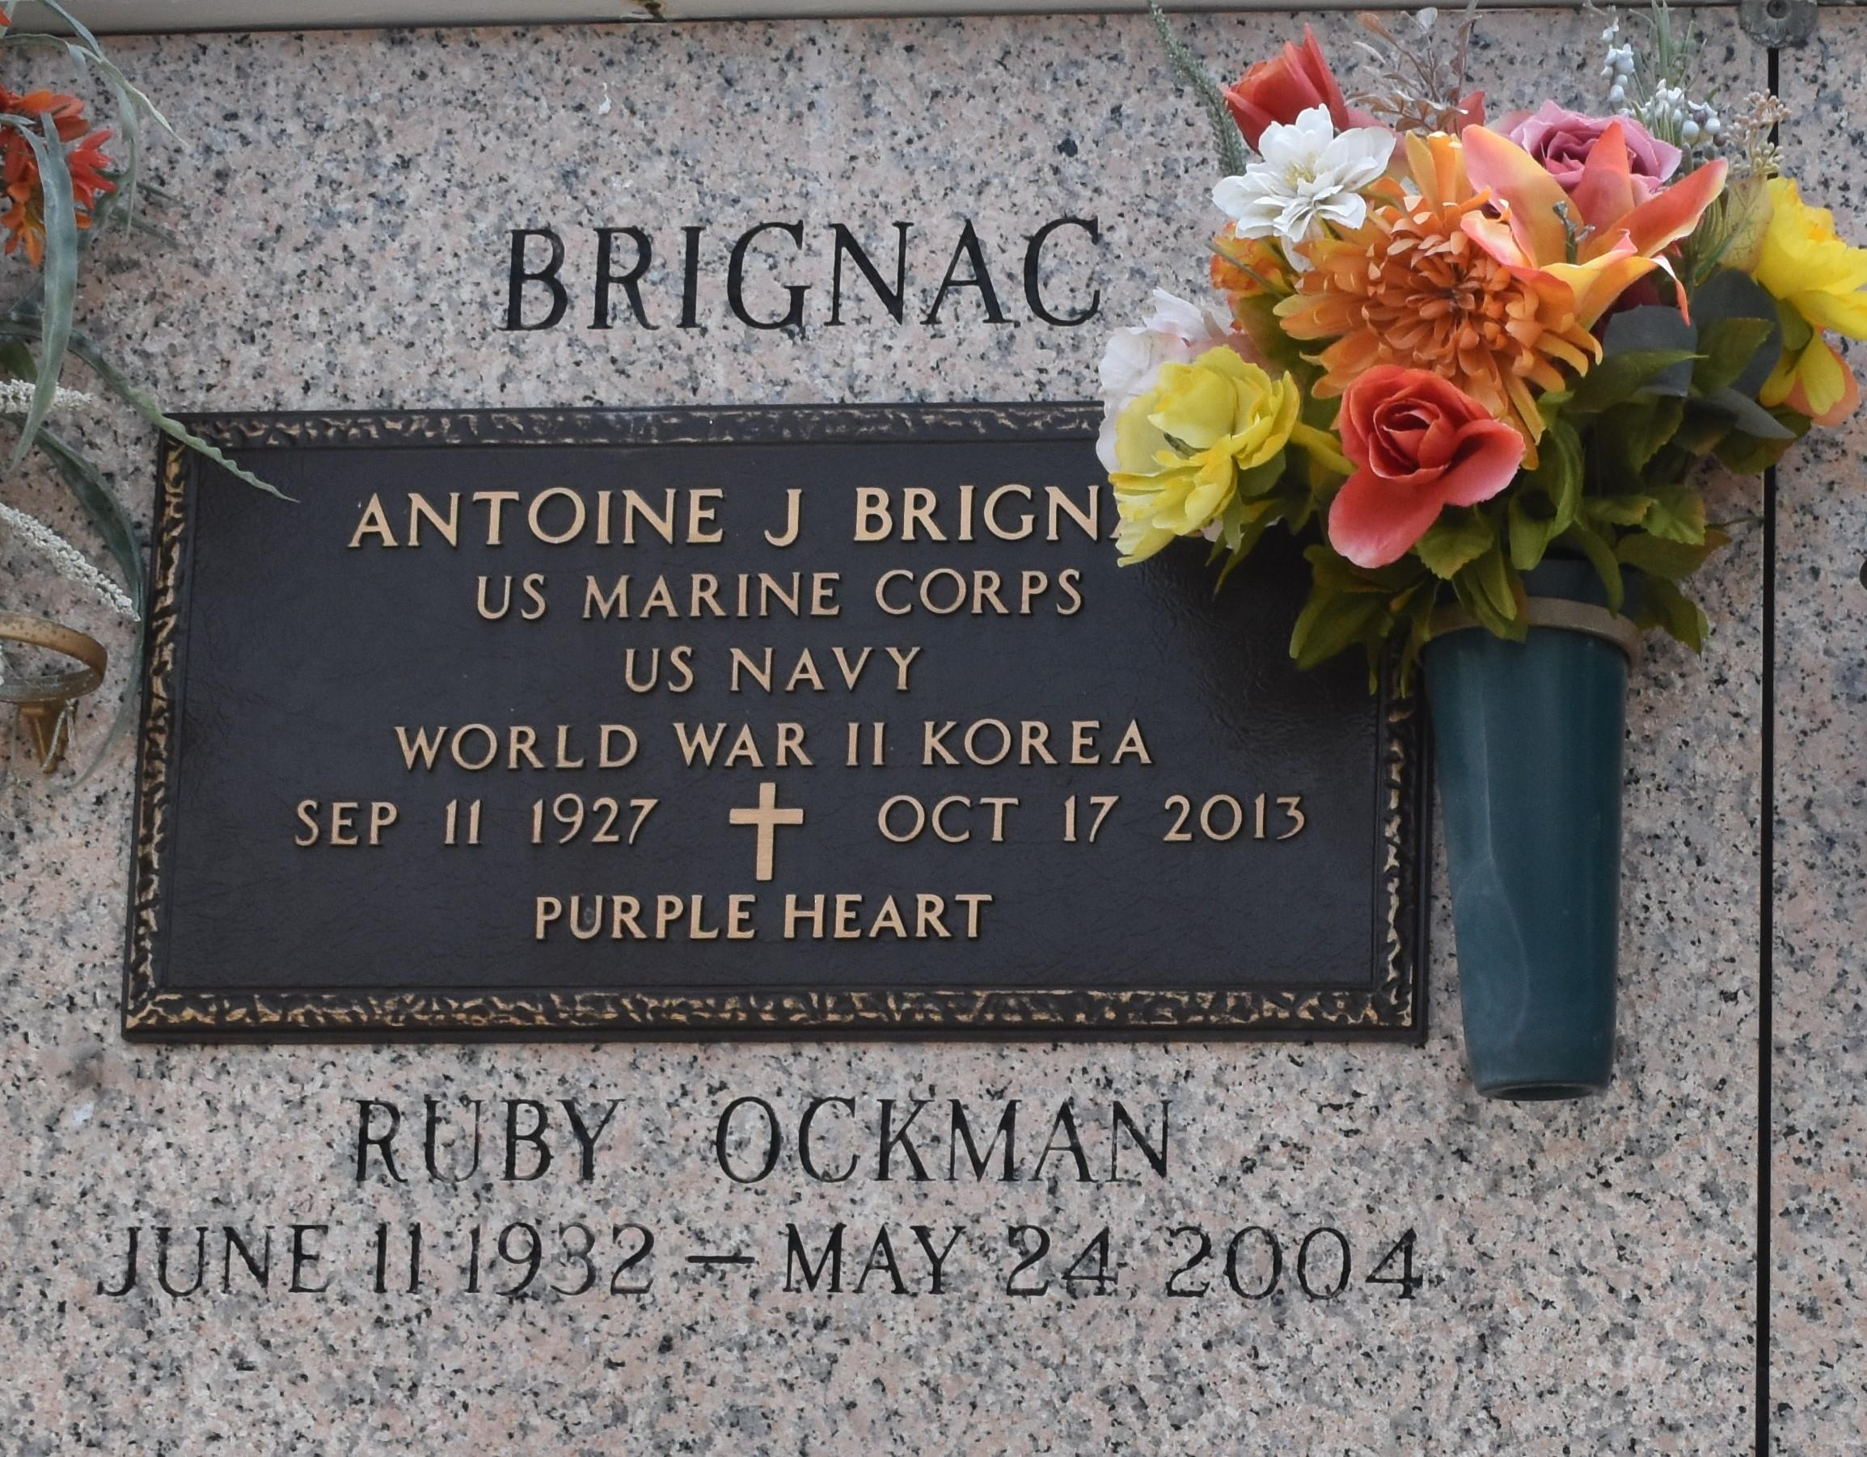

Antoine J. "Teet" Brignac, 86, died Thursday, Oct. 17, 2013. He was the beloved husband of Ruby Ockman Brignac, father of Rodney Brignac, Keith Brignac (Stacey), Lana Trepagnier (Colin) and Jamie Brignac, grandfather of Blake, Shelley, Rebakah, Charles and Bobby Brignac, Codi Gaubert and Lindsay Duhe, great-grandfather of Lexi, Maci and Luke, son of the late Joseph and Martha Simon Brignac, brother of Lawrence Brignac, Cecile Louque, Marian Adams and the late Francis Brignac, Russell Brignac and Loretta Guidry and brother-in-law of Hazel Tamplain, Roger Louque, Thomas Adams, Charles Calcagno, Gary Keating, Dorothy Brignac and the late Francis and Lloyd St. Martin, Marion Keating, Janice Oncale, Anna Lee Calcagno, Claude Guidry, Mildred and Elaine Brignac and Floyd Luminais. He was a native of Gramercy and a resident of LaPlace. He was a Navy veteran and a decorated disabled Marine veteran of the Korean War, retired from Colonial Sugar and a big LSU fan.

Relatives and friends are invited to attend services. Visitation will be held at MilletGuidry Funeral Home, 2806 W. Airline Highway, LaPlace, on Saturday, Oct. 19, 2013 from 8 a.m. to 9:30 a.m., followed by Mass at St. Joan of Arc Catholic Church in LaPlace at 10 a.m. Burial will follow in St. John Memorial Gardens in LaPlace. In lieu of flowers, the family asks for Masses, Sanctuary Light or donations to the Disabled American Veterans.

L'Observateur, LaPlace, Louisiana

Friday, October 18, 2013

Contributed by Jane Edson