Frank Brow Jr.

1923 – May 20, 2014

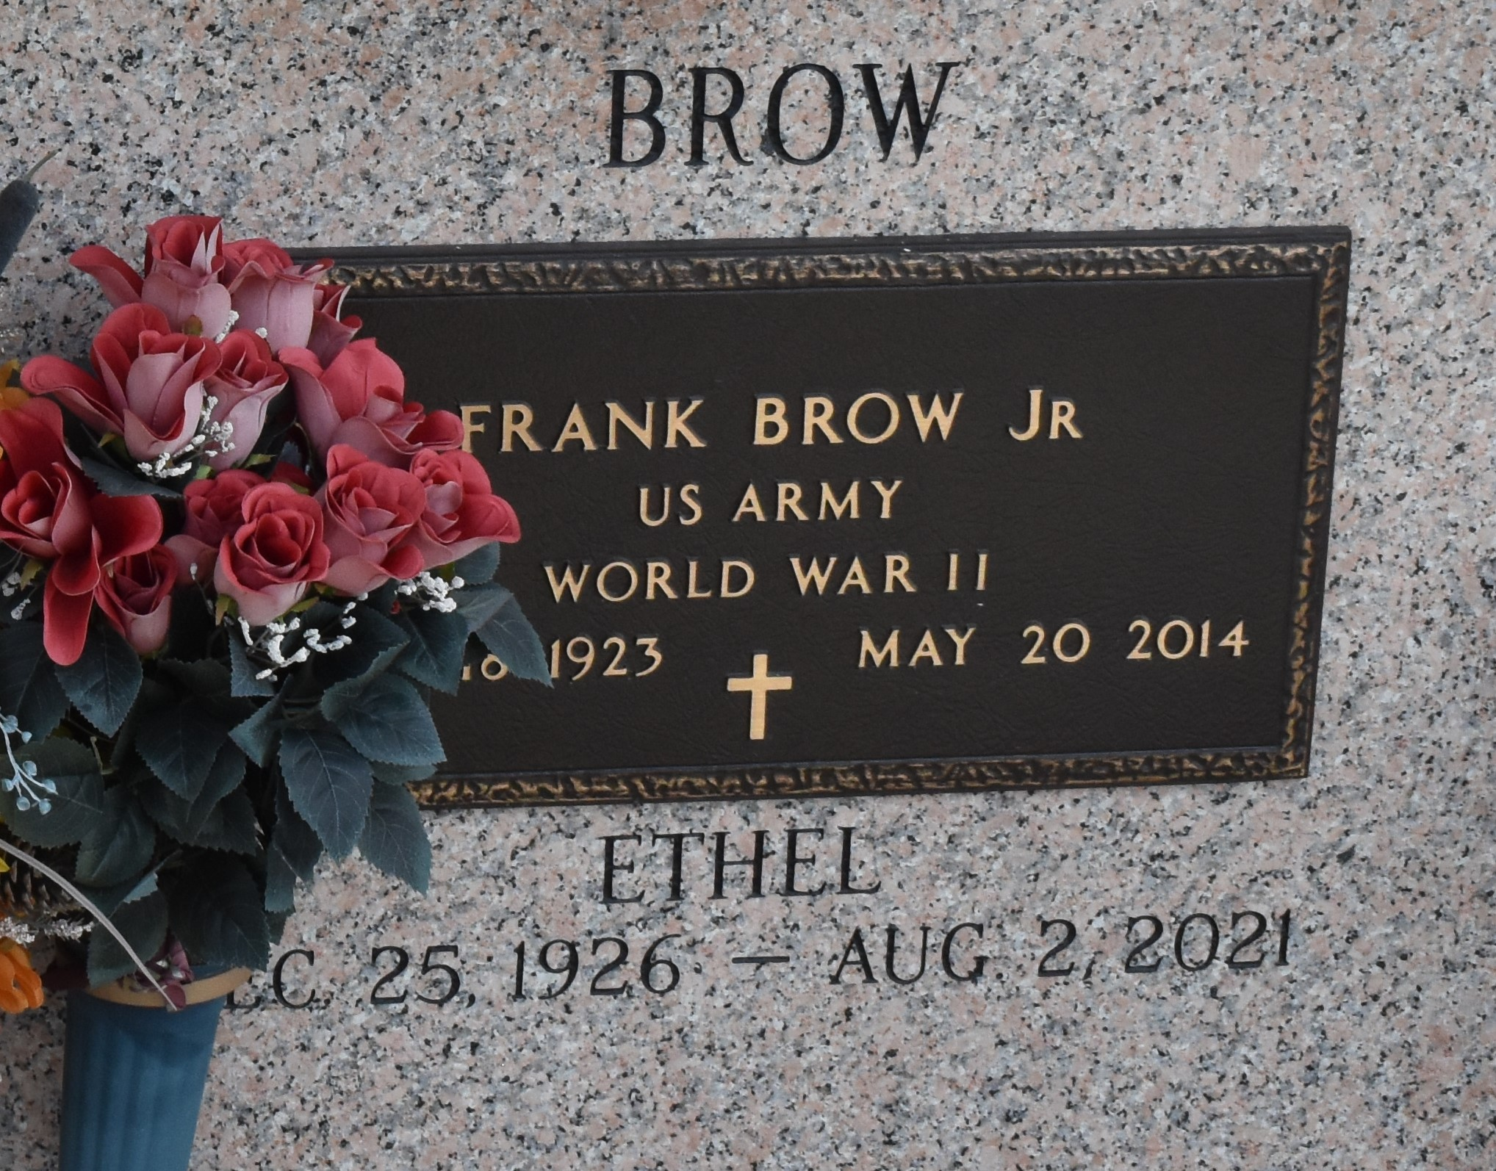

Frank Brow Jr., age 90, passed away on Tuesday, May 20, 2014. Husband of Ethel Brow. Son of the late Ellen and Frank Brow Sr. Father of Laverne August and Eloise Duhe. Grandfather of Angel August. Brother of the late Joseph Bobbler. Also survived by a host of other relatives and friends.

Services will be on Saturday, May 24, 2014 at 11:00am at Rising Star B.C. at 620 Cardinal St., Laplace, LA. Visitation from 9am until service time. Rev. Donald Ray August officiating. Interment in St. John Memorial Laplace, LA. Services Entrusted to Hobson Brown Funeral Home 134 Daisy St., Garyville, La 70051 985-535-2516

The Times-Picayune, New Orleans, Louisiana

May 21 to May 23, 2014