Chalanta Patrice Brown

1972 – April 13, 2017

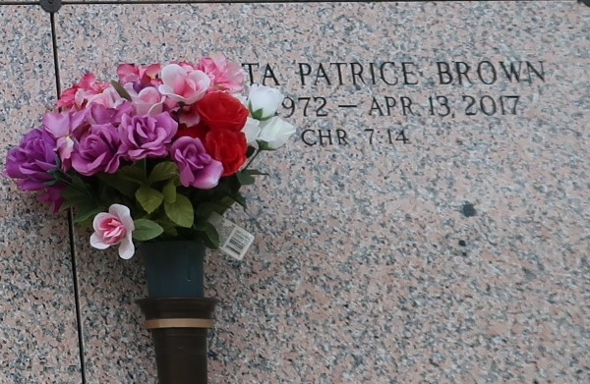

Chalanta Patrice Brown, age 44 years, departed this life on Thursday April 13, 2017, in St. Charles Parish.  
 Daughter of and Barbara Jean Sylvester (Melvin George Coleman Sr.) and the late Bradford Brown Jr. Mother of Bobbie Franklin Jr. and Dyraneshia D. Warren. Sister of LaBaron Joseph Sylvester Sr., Catherine Brown Martin and Bradtrel Jovon B. Anderson (Michael). Fiancé' of Joseph S. Williams Sr. Also, survived by a host of aunts, uncles, nieces, nephews, godchildren, in-laws, other relatives and friends.  
 Preceded in death by her husband Anthony Jefferson, a brother King Estus Honore (Peas) and three infant brothers. Grandparents Bradford Brown Sr. Laura Brown, Jacob Joseph Sylvester and Mayola King Houston.  
 A funeral service will be held on Saturday April 22,2017 at 11:00 am from First Community Antioch Baptist Church 10860 Hwy.3125 Gramercy, La. Pastor F. Gaines Sr., officiant. Visitation at the church after 9:00 am. Entombment St. John Memorial Gardens Laplace, LA.

The New Orleans Advocate (LA)

Apr. 20 to Apr. 22, 2017