Jeanette (Morgan) Brown

1948 – April 18, 2009

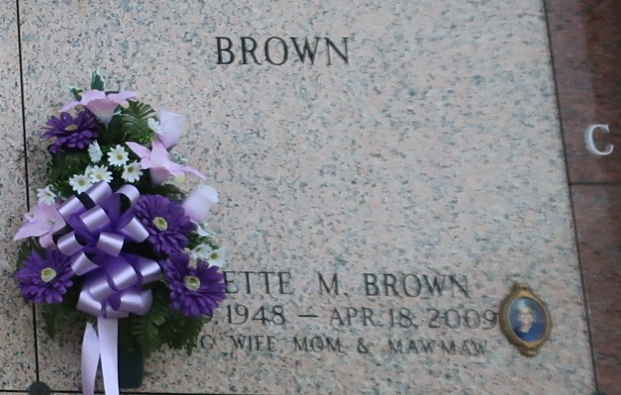

Jeanette Morgan Brown, age 61, a homemaker, a loving wife, mother, grandmother, sister, and friend, a native of Houma, La. and a resident of LaPlace, La., departed this life on Saturday, April 18, 2009 in LaPlace, La. Beloved wife of Rev. Dr. Augustus G. Brown, Jr. Mother of Augustus G. III, Todd Daniel, Eric Gordon and Natalie Nicole Brown. Grandmother of Austin Brown, Alexander Davison, A'Ja Gerielle, Aaliyah Nicole, Nayla Ny'Jae Brown and Destyni Renee' Watson, Sister of Joyce, Barbara Jean, Elaine, Freddie Mae, Maxine, Beryl, Kathleen, Patricia, Faye, Willie and Freddie Morgan. Also survived by sisters- and brothers-in-law, and a host of nieces, nephews, other relatives and friends. She was preceded in death by, her parents: Freddie and Elizabeth Morgan Sr.; brother, Eddie Wallace; and grandson, Alonzo Geremiah Mercadel.  
 Visitation will be held from 6:00-9:00 p.m. on Friday, April 24, 2009 at the Mt. Nebo Baptist Church, 198 West 2nd St., Hwy 44 (River Road), LaPlace, La. and a Celebration of Life Service on Saturday, April 25, 2009 at 11:00 am from the above name church, Mt. Nebo B.C. Rev. Dr. Augustus G. Brown, Jr., Pastor and Rev. Marc Nelson President of Central Union Missionary Baptist Association Officiating. All neighboring churches are invited to attend. Interment in St. John Memorial Gardens LaPlace, La. Service entrusted to Hobson Brown Funeral Home, Garyville, La. 70051; Information: (958) 535-2516.

Times-Picayune, The (New Orleans, LA)

Thursday, April 23, 2009

Contributed by Jane EdsonGaryville, La. 70051