Lelia (Joseph) Brown

September 18, 1935 – September 11, 2020

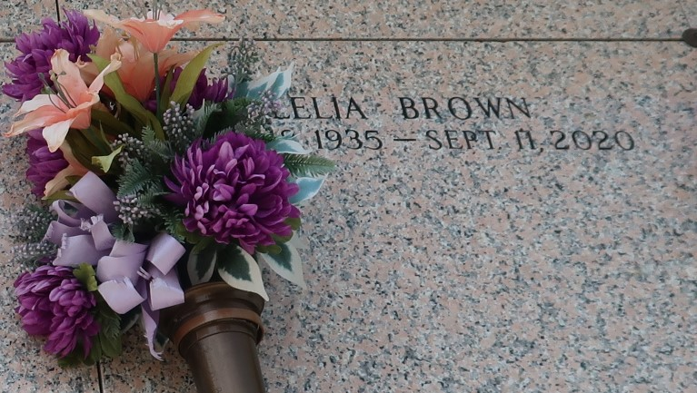

Ecclesiastes 3:2 (a) time to be born, on September 18, 1935, Lelia J. Brown, was born to the late Aldonia and Albert Joseph Sr.  
 Ecc 3:8 (a) A time to Love, she was the mother of Catherine (Tudie) Martin.  
Grandmother of RaQuen (Corey) Cotton, Richonda, and Richard (Qiana) Martin. Lelia is also survived by 10 Great grandchildren, and 1great great grandchild.  
 Ecc 3:2 (b) A time to die, on Friday, September 11, 2020, at 6:57pm. 84 years later Lelia Brown transitioned.  
 She is also survived by nieces, nephews, 2 god children, and a host of other relatives and friends.  
 WHAT A MIGHTY GOD WE SERVE, ANGELS BOW BEFORE HIM, Home going celebration on Tuesday, September 22, 2020 at Rising Star B.C. 620 Cardinal St. Laplace, LA, at 10:00am. Visitation on Monday at Milesville Memorial C.O.G.I.C., 129 Apple St., Laplace, LA, from 5-7PM and on Tuesday at Rising Star Baptist church from 9am until service time, Rev. Donald August Pastor. Interment in St. John Memorial, Laplace, LA.

Unknown source