Shirley Mae (Thacker) Brown

February 12, 1928 – August 26, 2015

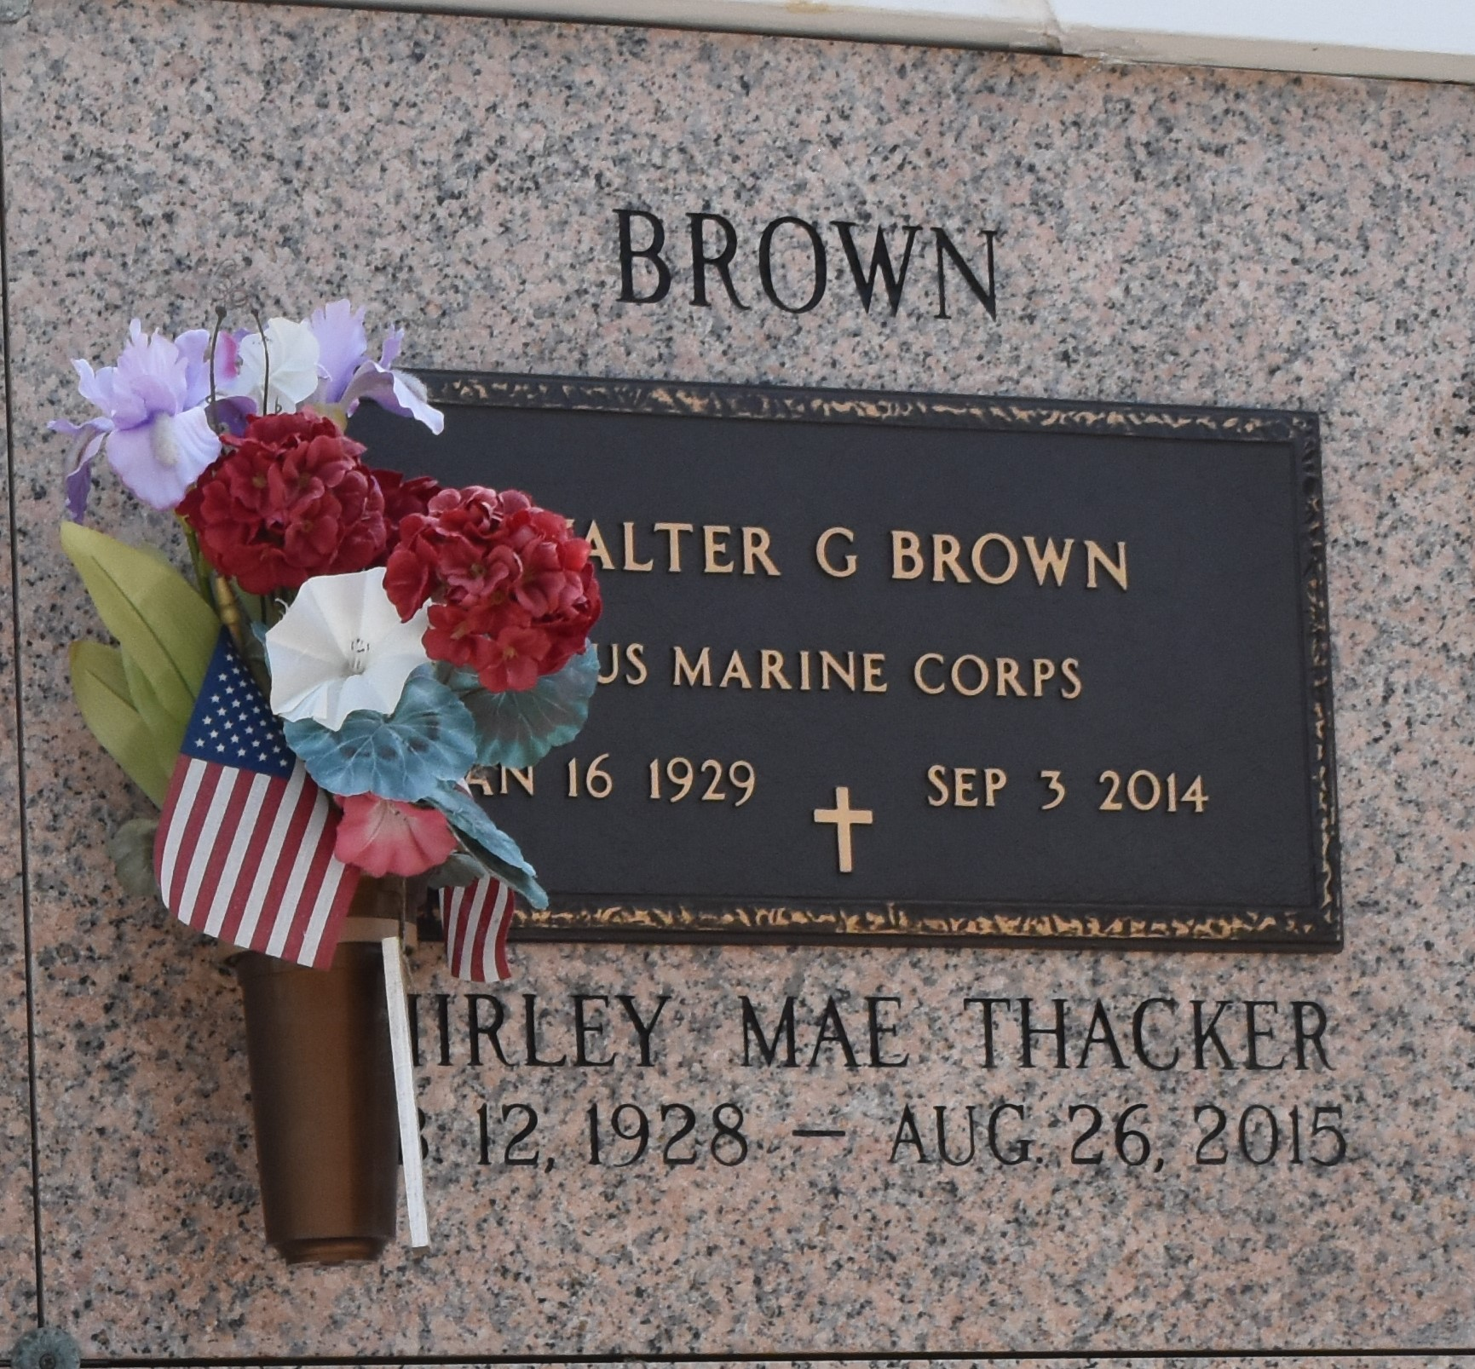

Shirley Mae Brown, 87, passed away peacefully on Wednesday, Aug. 26, 2015. She was a native of Lynchburg, Va., and a resident of LaPlace. Brown was the beloved wife of the late Walter G. Brown; mother of Pamela Brown, Sherry Brown Thompson and George Brown; daughter of the late Virginia Bryant and Corey Thacker; sister of Harry Thacker (Linda), Marjorie Dawson (Ernest), Vickie Beiman (Lee), Mildred Godsey, Frankie Owens (Deborah) and the late Nancy Radford (Ronnie); and grandmother of Derrik Brown. She is also survived by many nieces and nephews.

Relatives and friends are invited to attend the Funeral at the First United Methodist Church, 301 Bamboo Road in LaPlace, on Monday, Aug. 31 at 11 a.m. Visitation at the church is from 8:30 to 11 a.m. Interment will be in St. John Memorial Gardens. Arrangements are being handled by Millet-Guidry Funeral Home. In lieu of flowers, please consider a donation in Shirley's Memory to First United Methodist Church, 301 Bamboo Road in LaPlace, LA, 70068. To view or sign the online guest book, visit milletguidry.com.

L'Observateur, LaPlace, Louisiana

Thursday, August 27, 2015

Contributed by Jane Edson