Irene (Snyder) Burl

? 1, 1953 – November 10, 2020

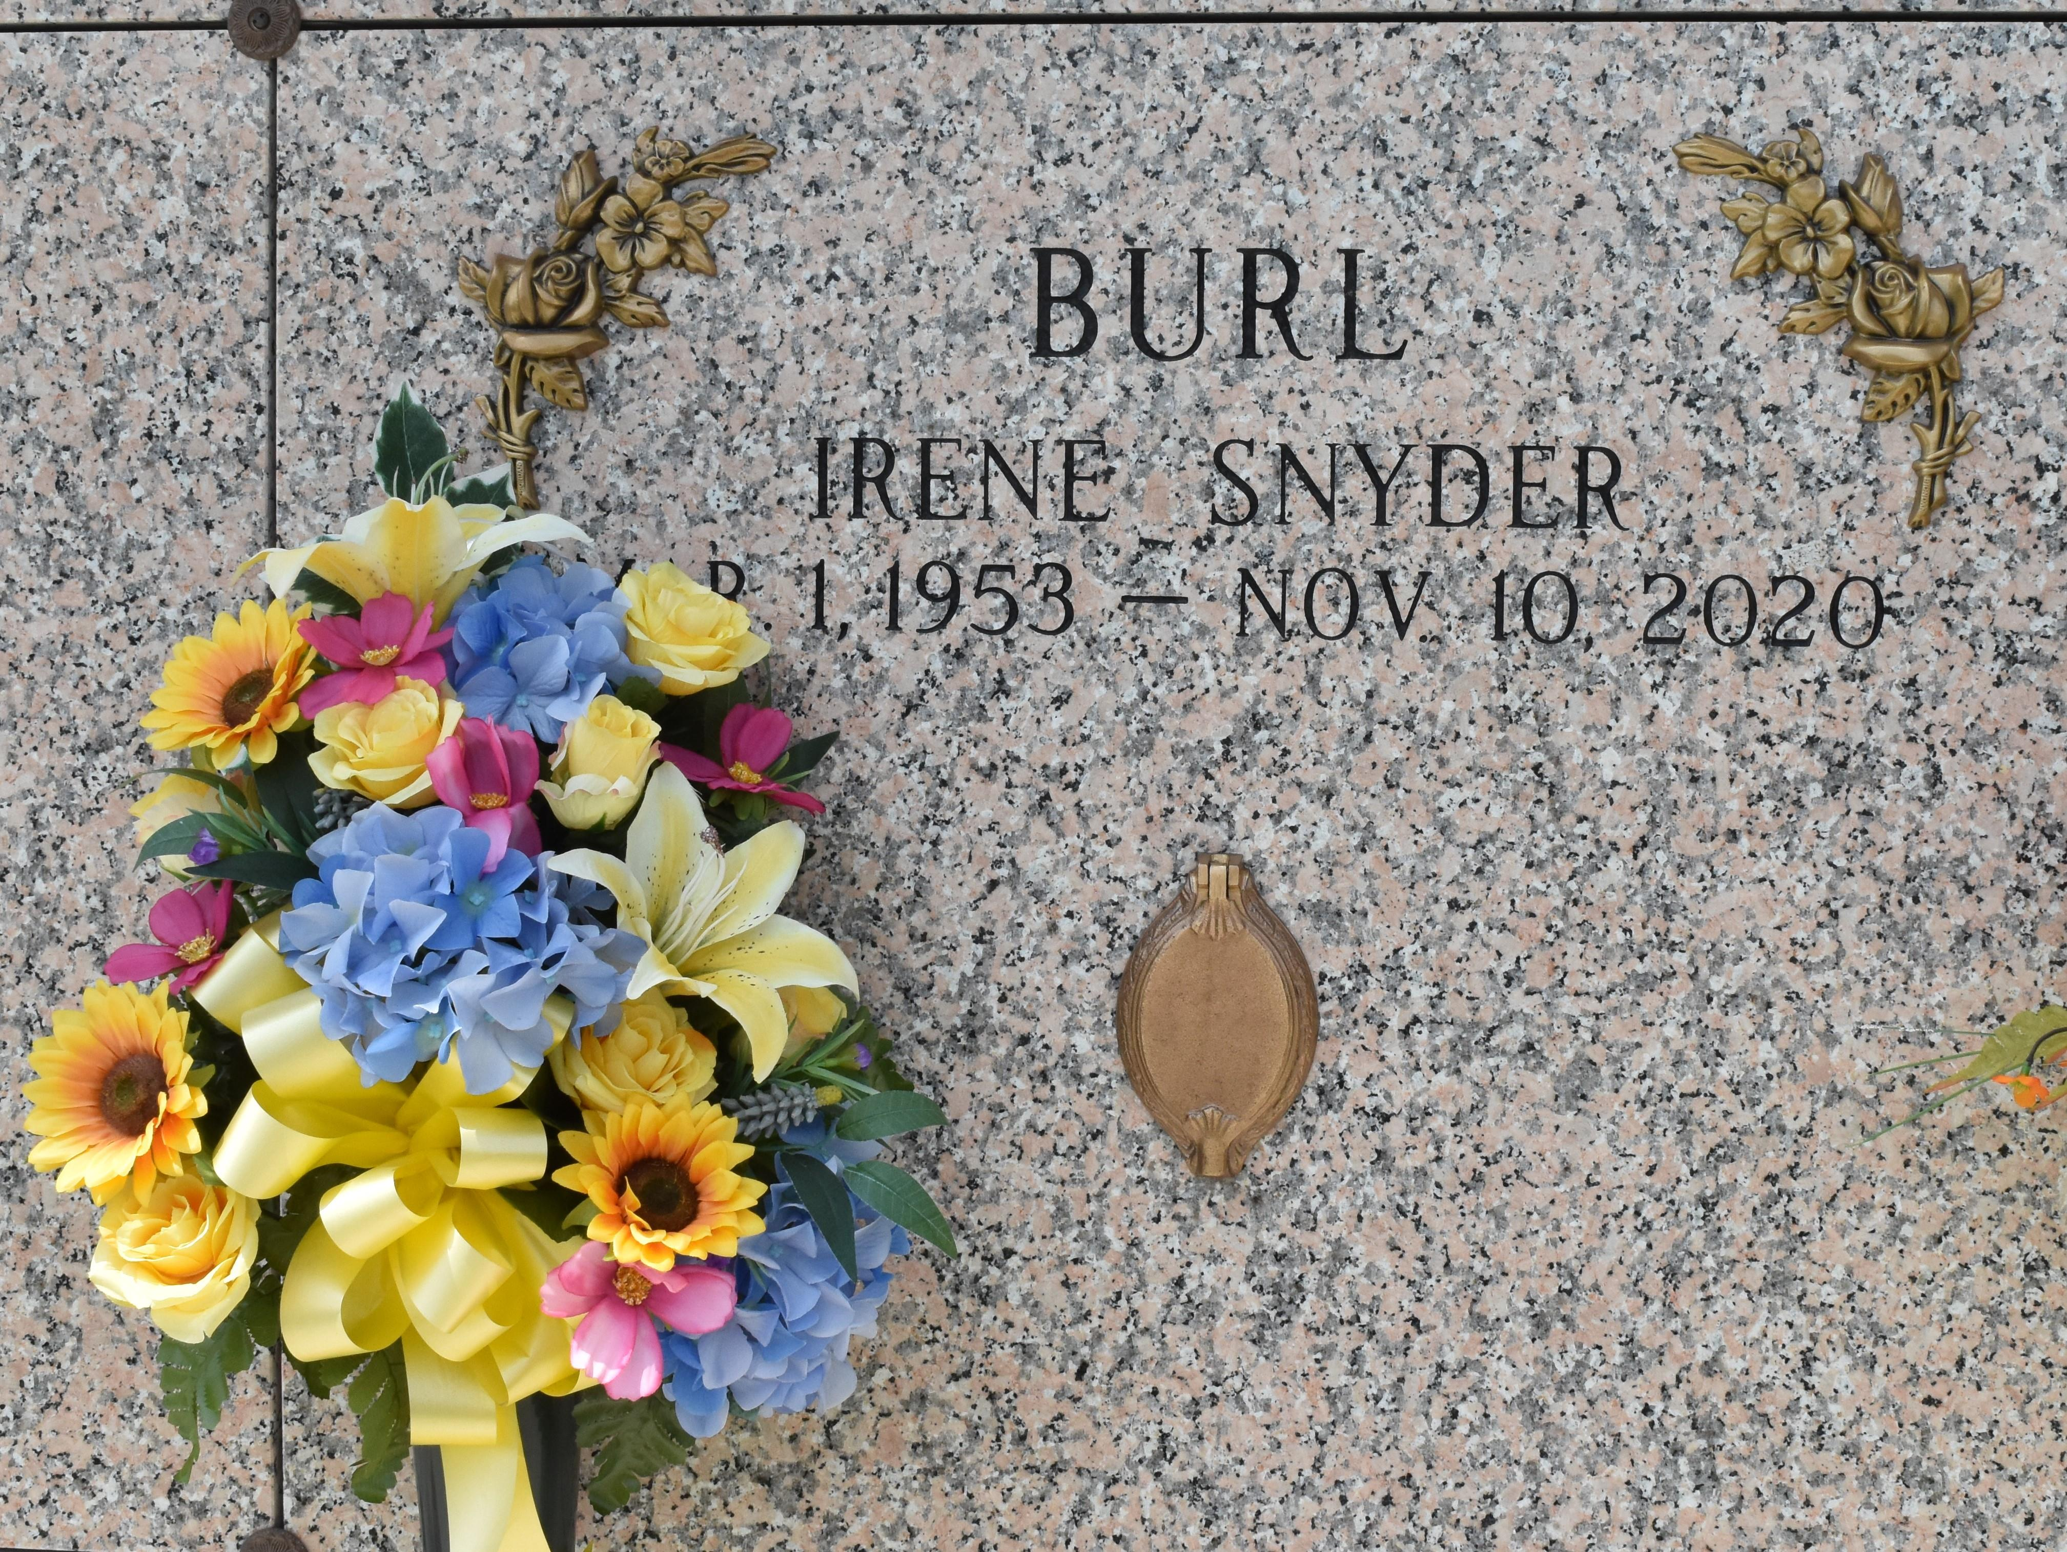

Irene Snyder Burl, an educator in St. John the Baptist Parish public school system for 44+ years departed this life on Monday, November 10, 2020 at her home, surrounded by her family at age 67. She was the daughter of the late Geniva Dent Hill and Peter Snyder, Jr. Mother of Chanda Snyder, Ali (Dr. Talawanga), Abdul (Kyroneika), and Akeem Burl. Grandmother of Alajuwon and Alaila Snyder, Kalyn, Aubrey, Konnor, Karter and Kalee Burl, Irene is survived by her 3 great-grandchildren, and a host of other relatives, friends and Colleagues.

Memorial celebration will be held on Tuesday, November 17, 2020 from 6:00 p.m.-8:00 p.m. at New Wine Christian Fellowship 1929 W Airline Hwy, LaPlace, LA. A Celebration of Life will take place on Wednesday, November 18, 2020 at 11:00 a.m. at the above name church, Viewing will begin at 9:00 a.m. until service time ONLY. Bishop Ronald Frank and Milesville Memorial C.O.G.I.C officiant/host church. Due to CDC Covid-19 restrictions, face mask and social distancing are required. Professional Services entrusted to the Caring Staff of Hobson Brown Funeral Home, 134 Daisy St., Garyville, La 70051, (985) 535-2516. Assisted by New Orleans Embalmer's.

The Times-Picayune, New Orleans, Louisiana

Nov. 15 to Nov. 17, 2020