Josephine (Parrino) Cali

May 12, 1924 – June 16, 2004

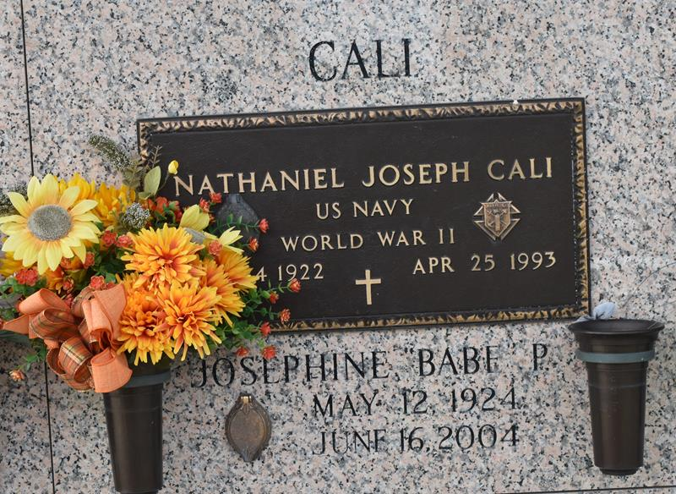

Josephine (Babe) Parrino Cali on Wednesday, June 16, 2004 at 12:50 AM. Beloved wife of the late Nathaniel (Nat) Cali. Mother of Natalie Cali, David Cali, Bernardine (Bernie) Cali Howard and Stephen Cali. Mother-in-law of Darlene and Sissy Cali and Randy Howard. Grandmother of David, Jr., Dustin, Stephen, Jr., Matthew and Luke Cali, Dawn and Marcie Allred McFarland, Jack Allred, Christopher and Jonathan Howard. Great-grandmother of Samuel McFarland. Age 80. A native of Chicago, Illinois and a resident of Laplace for the past 60 years.

Relatives and friends of the family, also members of the Ladies Altar Society, St. Joan of Arc Thrift Shop, River Parish Hospital Volunteers and Knights of Columbus are invited to attend services. Visitation at St. Joan of Arc Catholic Church, LaPlace on Friday, June 18, 2004 from 10am to 12 Noon. Followed by religious services in the church at 12 Noon. Burial in St. John Memorial Gardens, Laplace. In lieu of flowers, donations preferred to Make A Wish Foundation. Arrangements by MILLET-GUIDRY FUNERAL HOME, Laplace.

The Times-Picayune, New Orleans, Louisiana

June 17, 2004