Nathan J. Cambre

November 24, 1960 – January 7, 2010

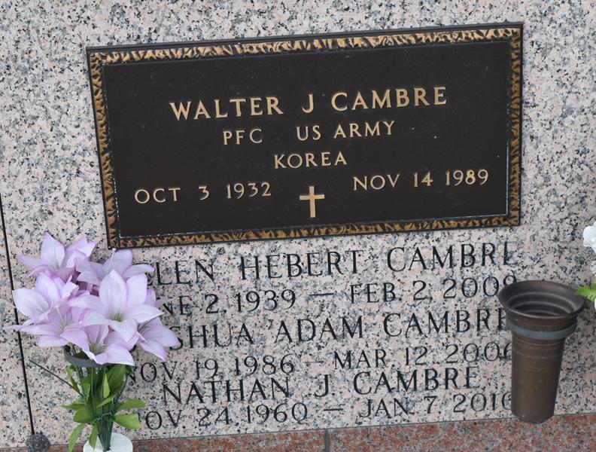

Nathan Cambre passed away on Thursday, January 7, 2010. Beloved son of the late Walter (Whitey) Sr. and Helen Hebert Cambre. Brother of Walter Cambre Jr. and wife Daina, Dorren Jouty and husband Kirk Sr., Kenneth and Travis Cambre. Age 49. A native and resident of LaPlace.

Relatives and friends are invited to attend services. Visitation at Millet-Guidry Funeral Home, 2806 W. Airline Hwy., LaPlace, La., on Friday, January 8, 2010 10:00 am to 12:00 noon. Followed by religious services in the funeral home chapel at 12:00 noon. Burial in St. John Memorial Gardens Cemetery, LaPlace, La.

The Times-Picayune, New Orleans, Louisiana

January 8, 2010