Kim (Vicknair) Capdeboscq

June 12, 1958 – May 20, 2012

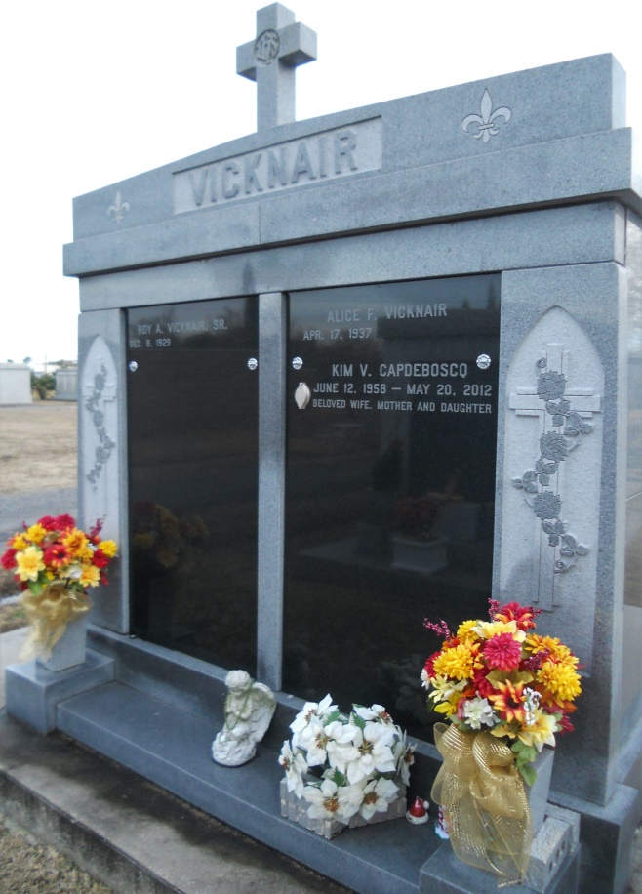

Photo by Team T Lo

Kim Vicknair Capdeboscq, 53, passed away Sunday, May 20, 2012.

She was the beloved wife of Jean Capdeboscq, mother of John and Chad Capdeboscq, daughter of Roy and Alice Faucheux Vicknair, sister of Roy Vicknair Jr. (Severine) and Robin Hoffmeister (Brad) and granddaughter of the late Lionel and Louise Faucheux and Wallace Vicknair and Elvina Brou.

She was a native and resident of LaPlace.

Relatives and friends are invited to attend services. Visitation will be held at Millet-Guidry Funeral Home, 2806 W. Airline Highway, LaPlace, on Wednesday, May 23, 2012, from 8 a.m. to 9:45 a.m., followed by Mass at St. Joan of Arc Catholic Church, 529 W. Fifth St., LaPlace, at 10 a.m. Burial will follow in St. John Memorial Gardens in LaPlace.

L’Observateur, LaPlace, LA; Wednesday, May 23, 2012